Project Online to Altus Migration
Migration Runsheet

March 2026
Contents
Overview 4
Roles and Responsibilities 5
Pre-Project Phase 8
Pre-Project Phase Steps 8
Pre-Project Phase Helper Guides 11
Setting up a Microsoft Team for Client Collaboration 11
Manage Microsoft Team Site Membership 13
Schedule a meeting using Microsoft Outlook Scheduling Poll 14
Pre-load custom fields from Project Online into the Migration Mapping Template 15
Pre-load column fields from Project Online Issues and Risks into the Migration Mapping Template 18
Update Data Validation Settings in Migration Mapping Template 19
Planning Phase 20
Planning Phase Steps 20
Planning Phase Helper Guides 25
Configure Financial Category Values 25
Update Altus Department Values 25
Configure Project Type Stage Gate Names and Order 27
Configure Enterprise Project Type Settings 29
Configure Fiscal Periods 30
Configure Global Resource Calendars 30
Configure Security Mapping to out of the box Altus roles 31
Configure Risk Matrix 32
Migration Phase 34
Migration Phase Steps 34
Migration Phase Helper Guides 45
Post Migration Checklist (Internal) 45
Post Migration Checklist (Client) 45
Training Phase 46
Training Phase Steps 46
Training Phase Helper Guides 47
Administrator Training Agenda 47
Project Manager Training Agenda 48
Team Member Training Agenda 48
Post Go-Live Phase 50
Post Go-Live Phase Steps 50
Post Go-Live Phase Helper Guides 51
Testing and Issue Resolution Support Process 51
Altus one-week priority support Process 56
How to create a Microsoft Forms Poll/Survey 56

Overview
This document serves as the official runsheet for the migration of data and activities from Project Online to Altus. Its primary purpose is to outline the key steps, order of operations, and roles involved in the migration process. By providing a clear overview of each task and assigning responsibilities, this runsheet aims to ensure all stakeholders understand what needs to be done, when, and by whom, helping to streamline the migration and minimise confusion or overlap.
The runsheet is designed to clarify the end-to-end flow of migration activities, from preparation and planning through to execution and completion. It provides a structured reference for project team members and stakeholders, supporting accountability and enabling smooth coordination throughout the migration to Altus.
Key steps involved are as follows:

Roles and Responsibilities
Role | Organisation | Name | Email | Responsibility
Implementation Consultant (IC) | Altus Implementation Partner |  |  | - Lead overall migration coordination and act as the primary delivery contact for the client PMO and project stakeholders.  - Confirm and stay within the boundaries of the migration scope.  - Providing regular updates on the status of the data migration  - Facilitate completion of the migration mapping template with the client.  - Confirm that all migration prerequisites are complete  - Coordinate the migration schedule, migration window, and system go-live with the client.  - Ensure stakeholders understand migration impacts, expected downtime, and post-migration activities.  - Manage issues and risks during migration and escalate where required.  - Oversee the priority support period and coordinate resolution of any post-migration issues.
Implementation Technical Consultant (TC) | Altus Implementation Partner |  |  | - Deploy base Altus product to production and non-production environments.  - Prepare and configure the technical migration tooling and scripts required for the extraction and import processes.  - Confirm connectivity and access to the source Project Online environment and the target Altus environment.  - Perform technical validation of the migration service account permissions and required Microsoft 365 components.  - Execute the extraction of data from Project Online including schedules, resources, configuration data, and associated artefacts.  - Prepare extracted data for import into Altus, including transformation and mapping based on the agreed migration templates.  - Execute the import of projects, resources, metadata, and associated records into the Altus Dataverse environment.  - Monitor migration execution logs and resolve technical migration errors where possible.  - Validate data integrity post-migration (record counts, relationships, schedule compatibility with Project Desktop).  - Assist with troubleshooting any technical issues encountered during migration execution.  - Support technical validation of integrations, reporting connections, and supporting services (Power BI, Power Automate, etc.).  - Communicate migration execution outcomes, logs, and any technical anomalies identified during the migration run to the implementation stakeholders.
Implementation Project Manager (IPM) | Client |  |  | - Act as the primary client point of contact for the migration project and coordinate internal stakeholders across PMO, IT, and business teams.  - Coordinate completion of the migration mapping template and ensure accurate information is provided by relevant subject matter experts.  - Ensure required Microsoft licences, service accounts, and environment access are provisioned in line with the migration prerequisites.  - Coordinate internal resources to support migration preparation activities, including configuration validation and testing readiness.  - Ensure key client team members are available to respond to migration questions and assist in resolving delivery barriers.  - Coordinate communication to impacted users regarding migration timing, system freeze periods and expected downtime.  - Confirm that the Project Online environment is stabilised prior to migration and coordinate the agreed change freeze period.  - Oversee the client validation process following migration, ensuring PMO and business users review migrated projects, resources, supporting data and facilitate the completion of client specific migration steps.  - Coordinate user acceptance confirmation that the migrated data in Altus is accurate and ready for operational use.  - Support cutover activities including user communication, enabling access to Altus and confirming readiness for go-live.  - Coordinate client participation during the priority support period to log, prioritise, and resolve any issues identified after migration during the agreed priority support period.
IT Administrator (IA) | Client |  |  | - Coordinating and executing the Altus Technical Readiness Steps (Provision of deployment account, Power App environment creation, Power BI workspace creation, global trusted consent etc..)  - Provision and Assignment of Microsoft Licenses for the deployment account and Altus Users.  - Creation of the appropriate Entra ID/AAD account setup for the deployment account and Altus security group membership mapping.  - Facilitating the deployment of the Altus for Microsoft Project Desktop add-in to all required users.  - Responsible for the decommissioning of Project Online after the priority support period has completed.
PMO Manager (PMOM) | Client |  |  | - Owner of the PPM system.  - Assist in identifying and resolving any PMO-related data issues identified during validation or priority support.  - Provide subject matter expertise on the organisation’s current Project Online configuration, governance model, and portfolio management practices.  - Validate the migration scope from a PMO perspective, including which projects, resources, and supporting artefacts should be migrated.  - Review and confirm field mappings, lookup tables, enterprise resources, calendars, and other governance configurations used in Project Online.  - Coordinate PMO input into migration preparation activities, including identifying inactive or archived projects that should not be migrated.

Pre-Project Phase

Pre-Project Phase Steps
ID | Task | Owner | Status | Notes
1 | Assign Project Team | IC |  | On formal acceptance of winning the job (Received a Purchase Order or written approval from the client), internally coordinate who will be implementation consultant and the technical consultants on this project
2 | Sales to Delivery Handover Meeting | IC |  | Organise an internal handover meeting from the Partner Manager/Pre-Sales team for some insight and background on the client and upcoming engagement.  Acquire Client contact details for initial communications.
3 | Create Client Collaboration Team Site | IC |  | Create a team site for the project following the steps outlined in these sections of this document:  - Setting up a Microsoft Team for Client Collaboration  - Manage Microsoft Team Site Membership
4 | Copy Project Templates to Team Site | IC |  | Download and copy the Project Online to Altus Delivery Collateral templates from the Partner Portal over to your Project Team Site:  - POL Migration Delivery Collateral  Download and copy the Project Online to Altus Migration Tooling from the Partner Portal over to your Project Team Site:  - Altus.Project.Online.Migration.Toolkit.2026.05.26.1.zip
5 | Create Internal Project in local PPM system | IC |  | Create a new Project in your internal PPM production system, ideally that should be Altus  This will be a place to track your implementation projects so your internal team can track the status of this project amongst all current projects across the organisation. Please follow your internal process on how to set this up and manage the project throughout its lifecycle.
6 | Make initial contact to client and organise the project kick-off meeting | IC |  | Reach out to your client contact/s. Introduce yourself and team and highlight the immediate steps you are working.  Propose some preferred dates and times for the initial Project Kick-off meeting. Be mindful of the client’s time zone. Use Microsoft Outlooks Scheduling Poll feature to assist the process.  Schedule a meeting using Microsoft Outlook Scheduling Poll  Ask for names, titles and email address of those who should attend. As a guide:  - Project Manager, our key contact to facilitate communications between the core team.  - A Microsoft 365 domain Administrator or IT Technical representatives to assist with technical readiness and Licensing discussion.  - PMO Lead and subject matter expert staff to assist with the clients Project online overview, access and assistance in completing the Migration data Mapping template  - Any key project champions from the team who will help translate the story from project online into Altus and assist your end-users as pro-active assistants. Typically, a Senior Project Manager or current project online subject matter expert that your internal team often rely on.  - Your project Change Manager if available.  Provide the agenda (in the PowerPoint deck of the kick-off meeting template), Also include the purpose and expected outcomes of the session.  Estimated duration for the initial kick off meeting is 2 to 3 hours.  Include links to Altus technical readiness  Request immediate access to clients Project Online instance to commence loading of the migration template.
7 | Pre-load the Custom fields and project register schema tables in the [03 - PO to Altus Migration - Scope and Field Mapper.xlsx] template. | TC |  | Login to clients Project Online instance to collect the appropriate project, task, resource custom field data as outlined in the ‘Pre-load custom fields from Project Online into the Migration Mapping Template’ steps below.  Then collect the risk and issue register field data as outlined in the ‘Pre-load column fields from Project Online Issues and Risks into the Migration Mapping Template’ steps below.
8 | Update the Data Validation Settings to include the correct value ranges from the newly loaded table content | TC |  | Update the Data Validation Settings to include the correct value ranges from the newly loaded table content as per the steps outlined below in the ‘Update Data Validation Settings in Migration Mapping Template’ section

Pre-Project Phase Helper Guides

Setting up a Microsoft Team for Client Collaboration
- In Microsoft Teams, create a new team site
  - 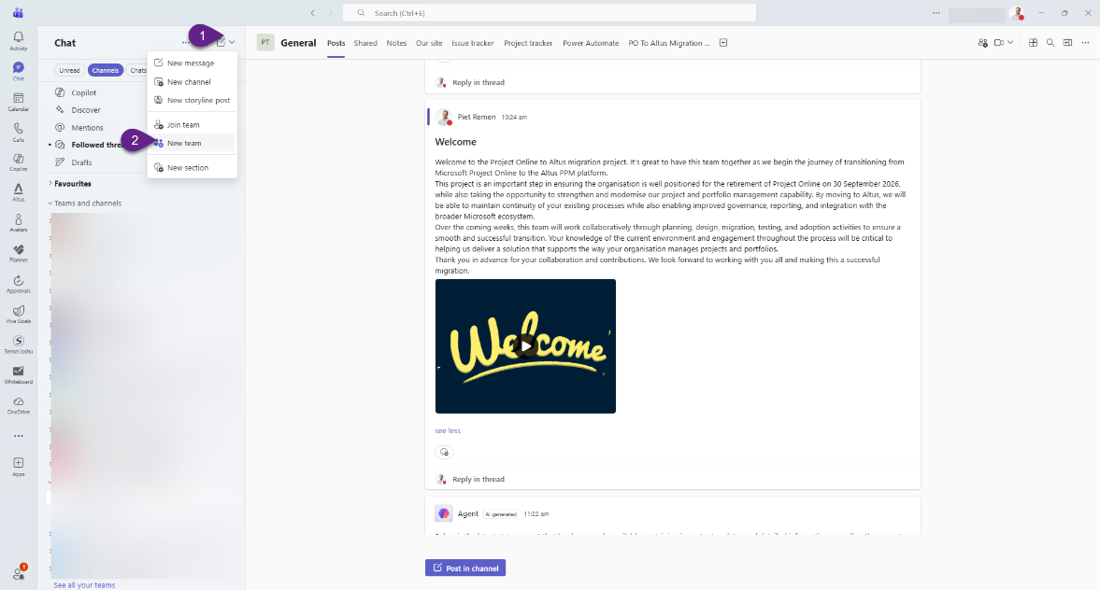
- Select the "More create team options" link to view a list of out of the box team templates. Select the [Manage a Project] template, click use template
  - 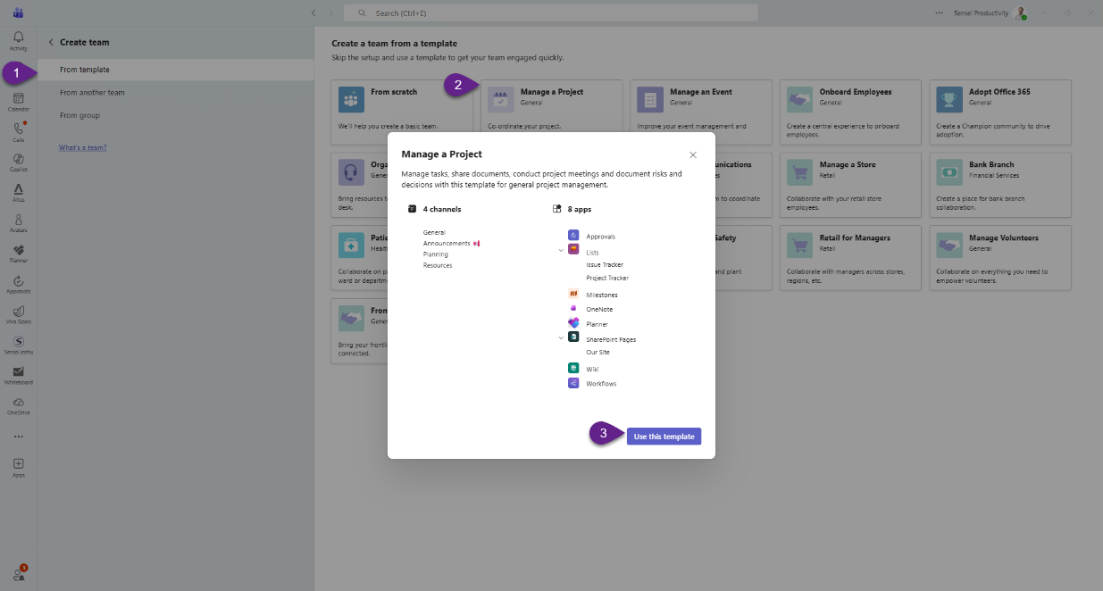
- Enter a name [Client Name - PO to Altus Migration] and a description. Click Create to create the site.
  - 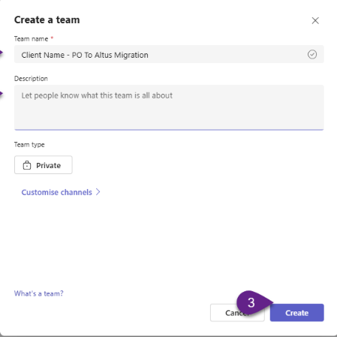
- Once the team is created, add in the appropriate team members to access the system, noting you can come back to adding external client members later, once they are confirmed.
  - 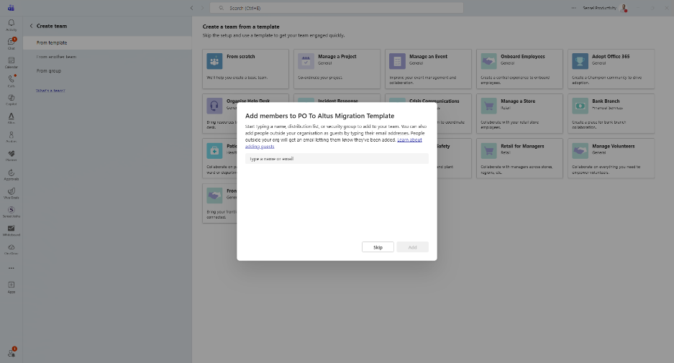
- Add Microsoft Planner to the team site
  - Add in a Planner Plan to the project to track key dates and activities. Click on the + icon in the top right section of the team
    - 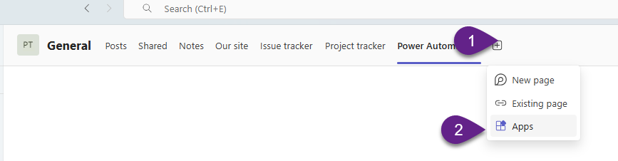
  - Search and select the planner option
    - 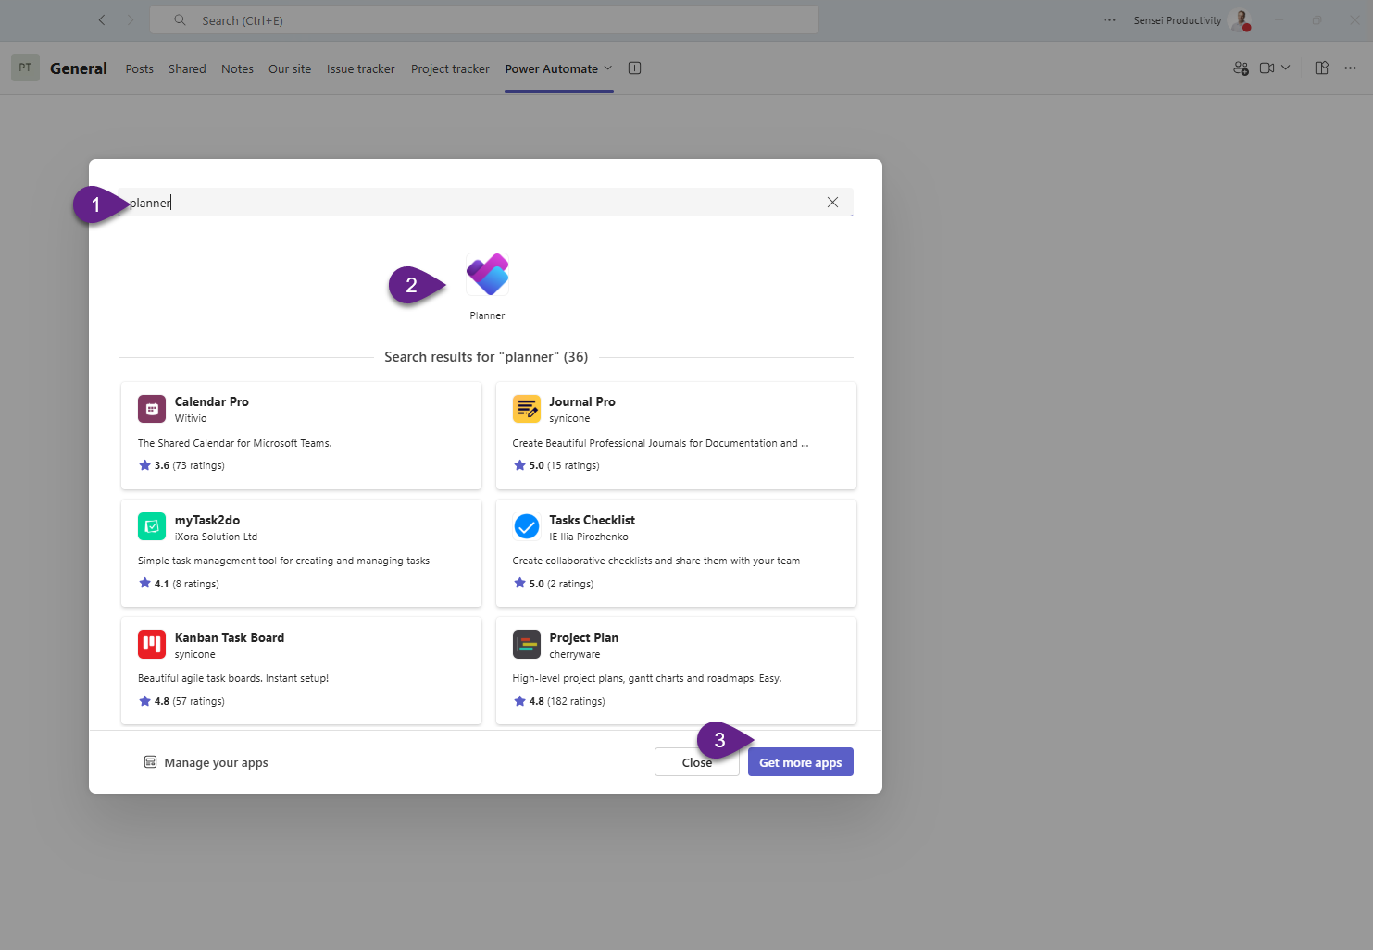
    - Follow the prompts to proceed. When asked to create a new plan or add an existing plan, create a new plan, or alternatively if you have a template to use, first create a copy of that and then link that plan to this tab. Rename the tab to ‘Project Plan’.
- Remove the Project Tracker list provided in the template.
  - Right click on the Project Tracker Tab and select the remove option
    - 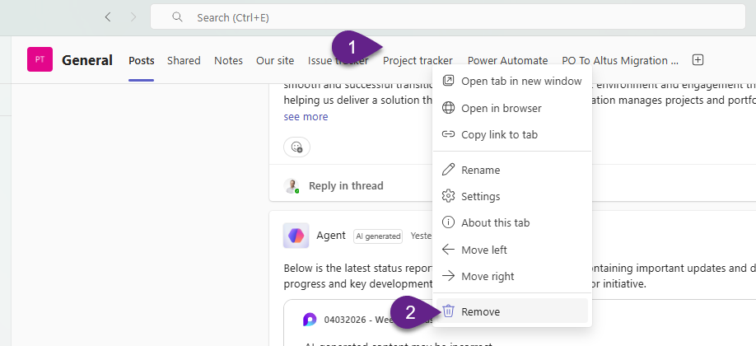
- Delete Unused Channels. Right click on the channel name and select delete.
  - Announcement
  - Planning
  - Resources
- OPTIONAL: If you need to have a safe space to store documents or post chats internally without the client, consider creating a private channel within this Team site and only share this with the necessary internal members.
  - Click the three dots (…) on the right of the Team Site name and select Add Chanel.
    - 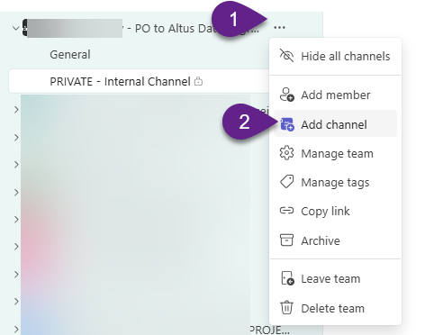
    - Enter a name like “PRIVATE - Internal Chanel”. Click Create.
      - 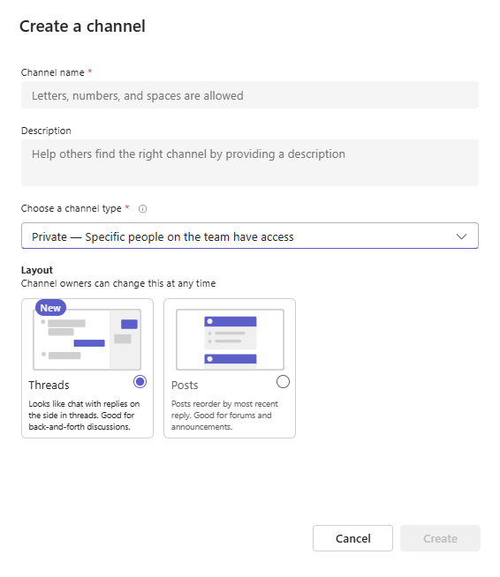
    - Add the appropriate internal team members.

Manage Microsoft Team Site Membership
- Open Microsoft Teams and locate your clients team site
- Click on the … to the right of the team’s name and select Manage Users
  - 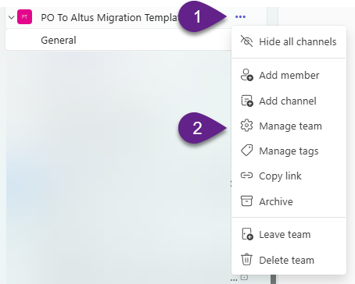
- Click on the Members tab and select + Add Member
  - 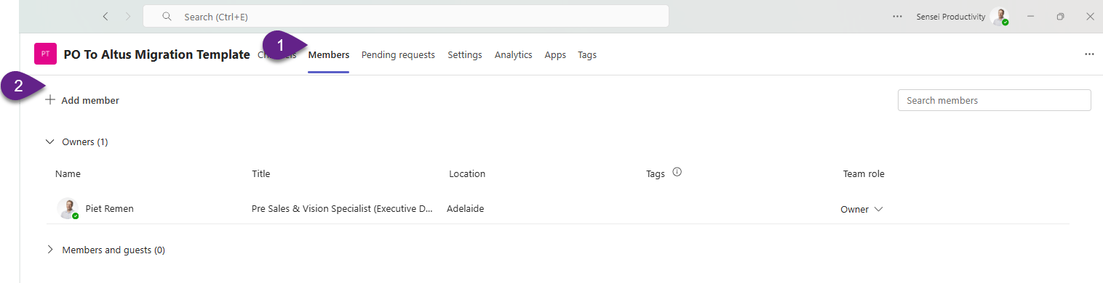
- Type in the full email address if an external (guest) account from the client or search for the name if an internal staff member.
  - 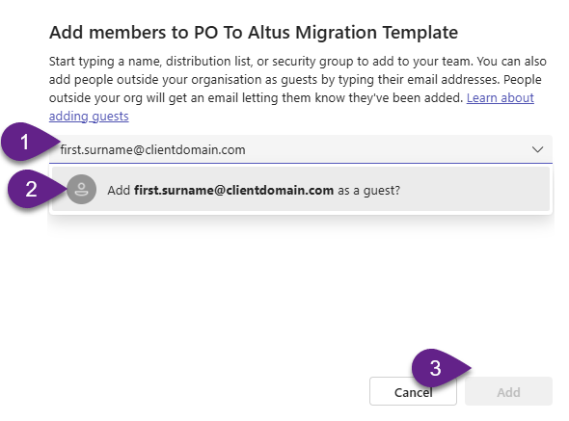

Schedule a meeting using Microsoft Outlook Scheduling Poll
- In Microsoft Outlook, create a new meeting email
- Open a new email message addressed to the attendees you want to invite (Containing internal and external emails).
- In the toolbar find and click on the Scheduling Poll button
- In the insert toolbar menu select Scheduling Poll
  - 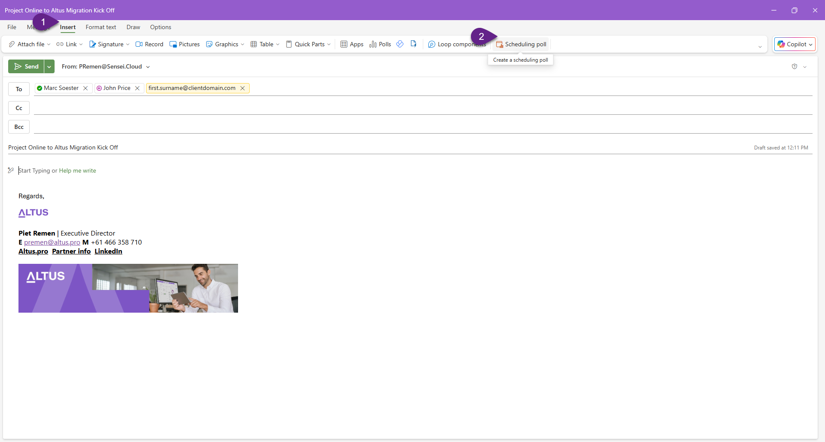
- Select suggested meeting times. A side panel will appear showing the Outlook calendars of people in your organisation (if available).
  - 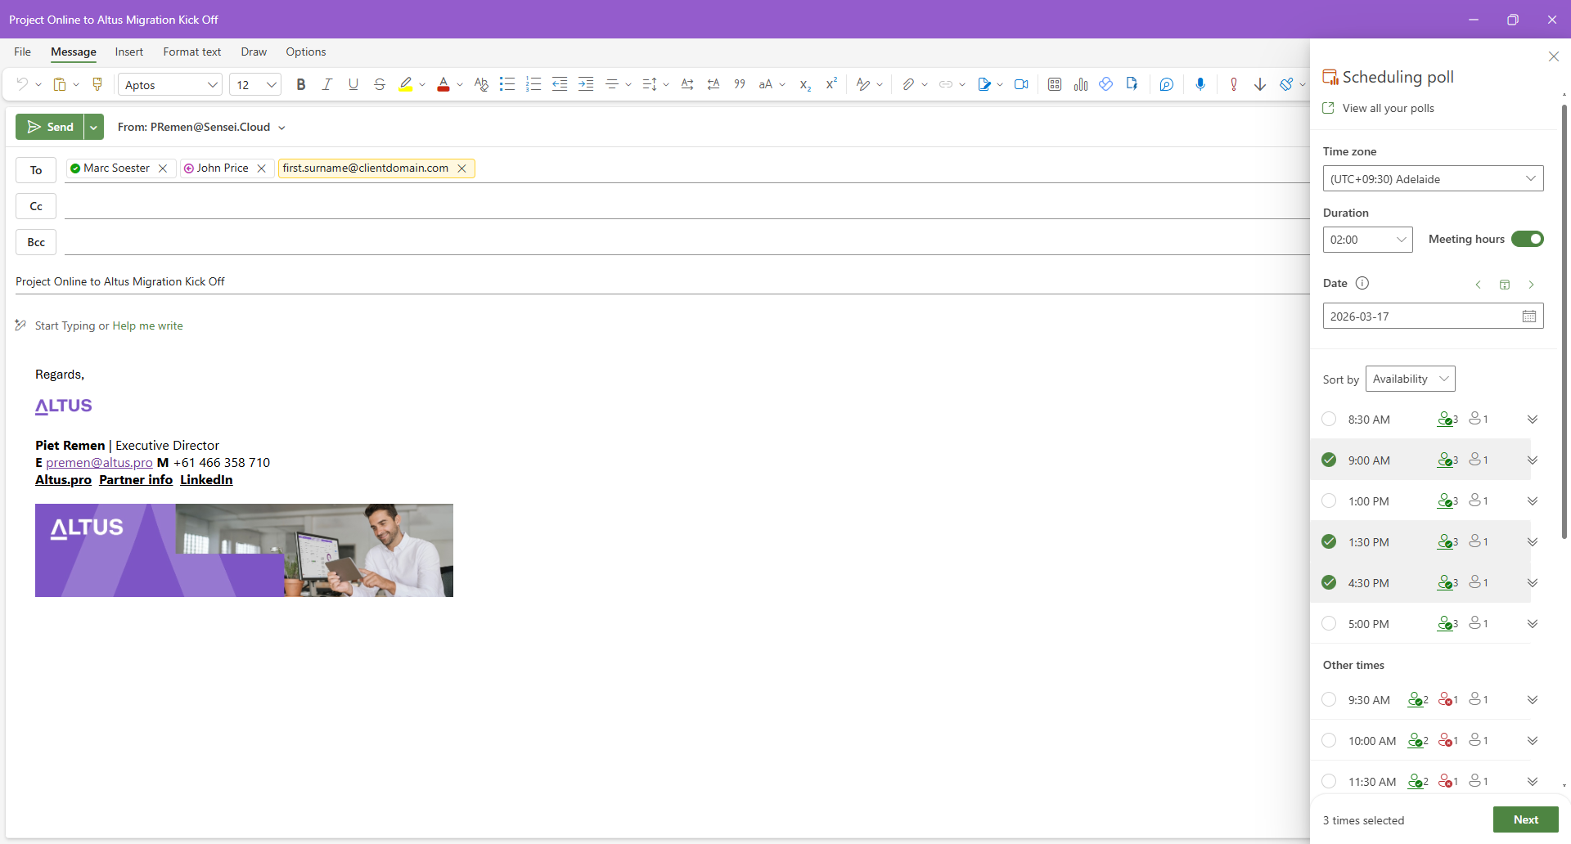
- You can select several possible meeting times. For external clients, Outlook will not see their calendars, so simply propose a few time options. Check time zone settings. At the bottom of the panel you can choose your time zone. Recipients will automatically see the times converted to their own time zone in the poll. NOTE, selecting times for a particular date will hold if then moving to other dates and selecting multiple date/time options.
  - 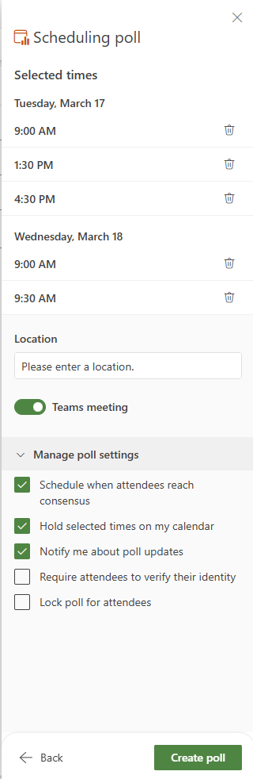
- When ready, Insert the poll into the email. Click “Add to email”. The poll will appear in the email body with a link where attendees can vote.
- Include the relevant content within the email like purpose, agenda, outcomes
- Send the email
- Recipients who receive the email will click the link, vote for the times that suit them, and Outlook will show you the responses.
- You can choose to automatically schedule the meeting once a consensus is reached.

Pre-load custom fields from Project Online into the Migration Mapping Template
In reference to the [03 - PO to Altus Migration - Scope and Field Mapper.xlsx] template, before handing the template over to the client to complete, you’ll need to first prepare the template and pre-load the tables in the [PO Project Custom Fields], [PO Task Custom Fields], [PO Resource Custom Fields] tabs
- Attain Administrator access to the clients Project Online instance.
- Login and navigate to Project Online > PWA Settings > Enterprise Custom Fields and Lookups in the Settings section
  - 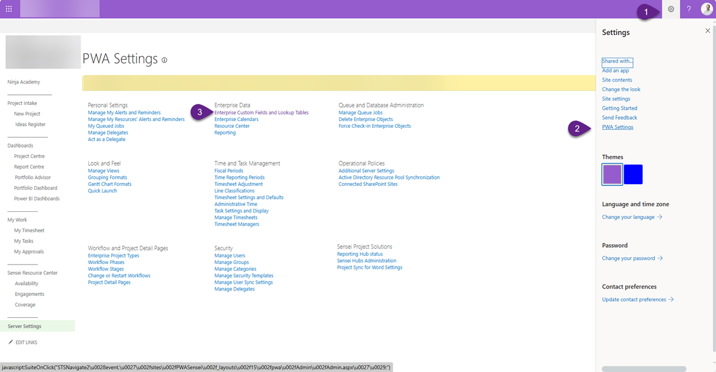
- Use the Developer tools (F12) in the browser to copy out the field settings table or preferably use the project online API using the following steps, plus the screen shot examples below:
https://clientdomain.sharepoint.com/sites/PWA/_api/ProjectServer/CustomFields?$expand=EntityType,LookupTable&$select=Name,DepartmentId,EntityType/Name,FieldType,IsRequired,IsWorkflowControlled,Formula,GraphicalIndicatorNonSummary,GraphicalIndicatorProjectSummary,GraphicalIndicatorSummary,LookupTable/Name
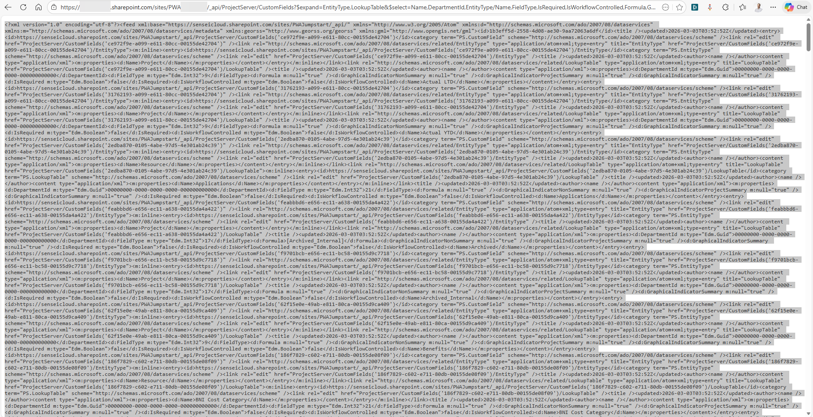
- Take that output, save it in a text file (notepad) and use your local copilot AI tool (https://m365.cloud.microsoft/chat/?auth=2&home=1) to format it in the same table layout used by this template. AI prompt example:
"Can you translate the attached XML into a downloadable Excel table format. Ensure there is one row per Custom Field only and expand tables/segments as needed to accurately extract the available field settings. Use a deep analysis approach to accurately capture this data. A single worksheet (CustomFields) with these columns:
CustomFieldGuid, CustomFieldUrl, EntityType, FieldTypeLabel , DisplayName, FieldType, 'DepartmentId' and 'Department Name' value if possiblle, IsRequired, IsWorkflowControlled, IsGraphicalIndicator (best effort), LookupTableName (best-effort if present in the same segment), Formula (best-effort if present in the same segment - If the field has a value return "Yes", else "No"), LastUpdated, Formula (best-effort if present in the same segment),
Order by EntityType, then by DisplayName.
Make a copy of this data in a second worksheet, but only include the following fields in this order:
PO Field Name (DisplayName), PO Department (DepartmentLabel), PO Data Type (EntityType), PO Field Type (FieldTypeLabel), PO Required (IsRequired), PO Formula (Formula), PO Graphical Indicator (IsGraphicalIndicator), Source Lookup Table (LookupTableName), Last Updated"
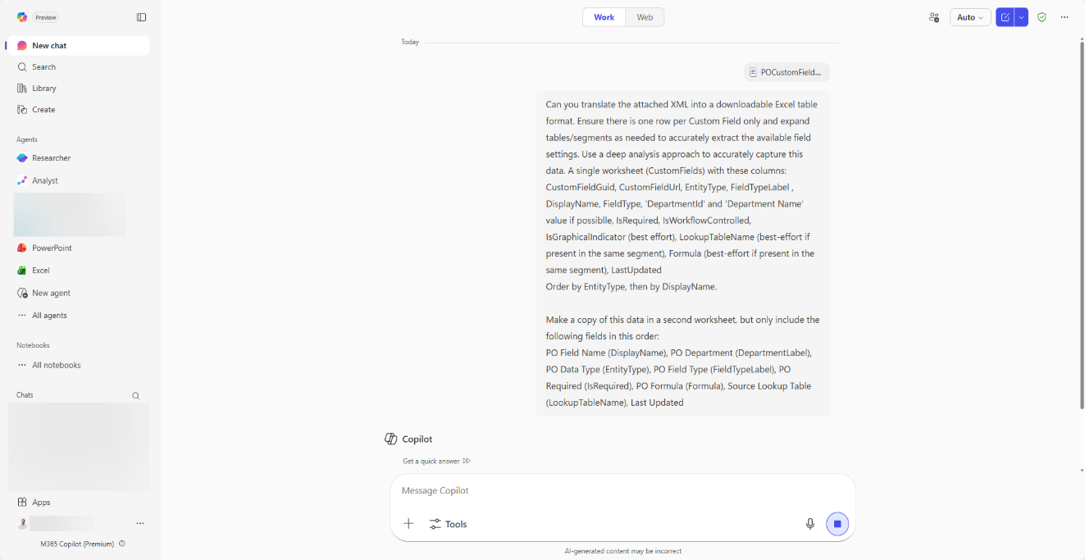
- Cross check and validate the outputs transformed by AI to ensure accuracy
- Further Reading on the PS.CustomFieldType enumeration (ps.js) can be found at the following Microsoft Learn article
  - https://learn.microsoft.com/en-us/previous-versions/office/project-javascript-api/jj669472(v=office.15)#members
- Paste this table data into the correct table in the [PO Project Custom Fields], [PO Task Custom Fields], [PO Resource Custom Fields] tab, making sure the column names are correctly aligned to the order within the spreadsheet. If not, ask Copilot to order it correctly.
  - 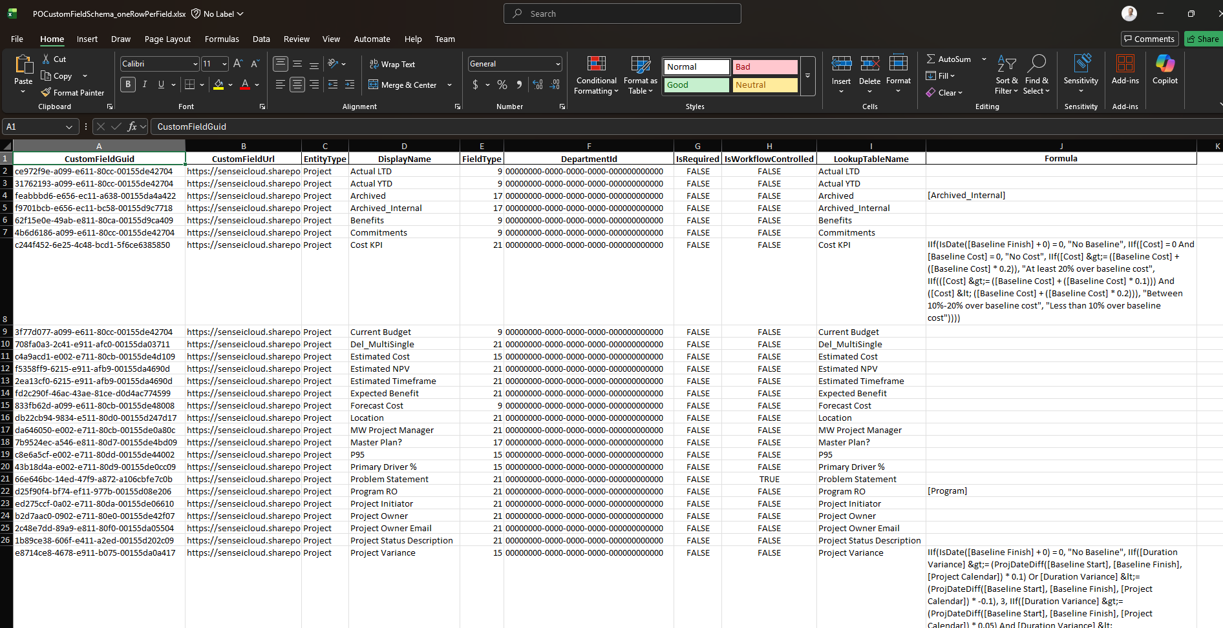
- For each of the three worksheets, ensure you delete the custom field not appropriate for that type. For example, [PO Project Custom fields] should only have the Project Data Type/Entity fields and delete the Task and resource ones.
- Ensure the first column [PO Field Name] is sorted in alphabetical order so the VLOOKUP function in the mapping worksheets work correctly.

Pre-load column fields from Project Online Issues and Risks into the Migration Mapping Template

In reference to the [03 - PO to Altus Migration - Scope and Field Mapper.xlsx] template, before handing the template over to the client to complete, you’ll need to first prepare the template and pre-load the tables in the [PO Issues Fields] and [PO Risks Fields] tabs:
- Attain Administrator access to the clients Project Online instance.
- Login and navigate to Project Online.
- Navigate to an existing project site or create a new one project with a blank project site using the latest SharePoint site template to use as the master list.
- Navigate to the issues SharePoint List
- Click the cog in the top right and select [List Settings]
- Use Microsoft Copilot in the browser to format the custom field table in an excel format so you can paste that table data. An example AI Prompt
  - "Create a complete copy of the "columns" table on this current page in an Excel table format I can use"
  - 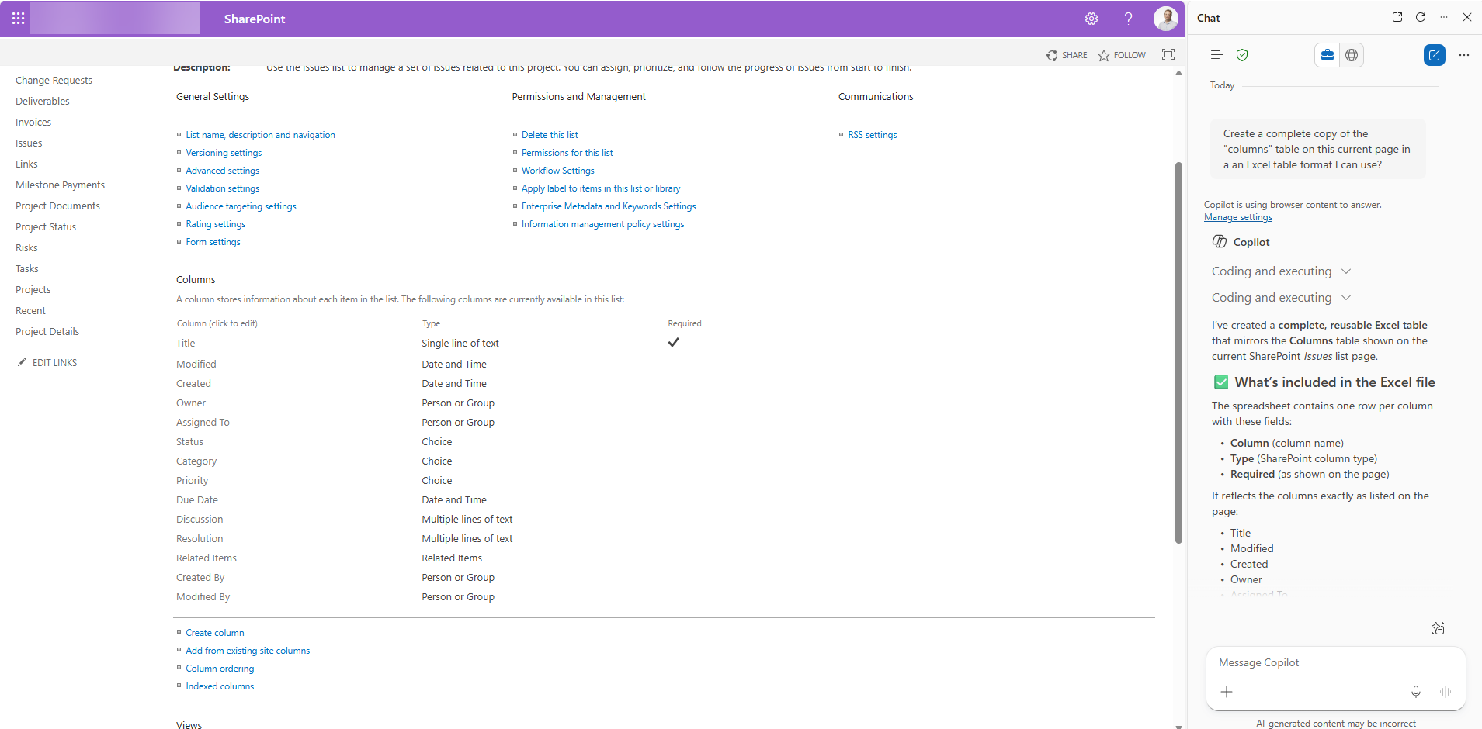
- NOTE: For old SharePoint lists that are not using the modern SharePoint experience, you will need to hack manually craft the URL.
  - 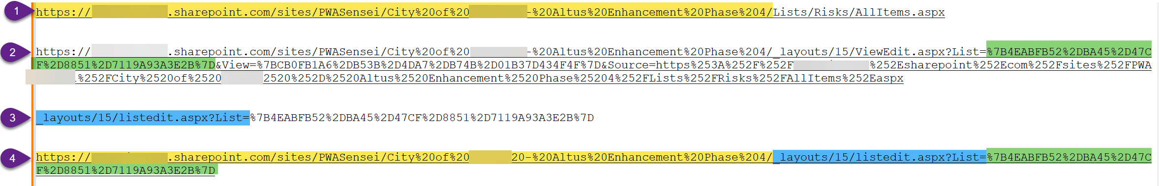
  - The URL from the default page when you click on the list.
  - The URL if you click …>Modify this View
  - paste the blue part to the end of your yellow highlighted URL part in step 1 of the image above.
_layouts/15/listedit.aspx?List=
  - Append the ID value to the end of your new URL taken from the green highlighted area in step 2 of the image above.
- Ensure the first column [Column Name] is sorted in alphabetical order so the VLOOKUP function in the mapping worksheets work correctly.
  - 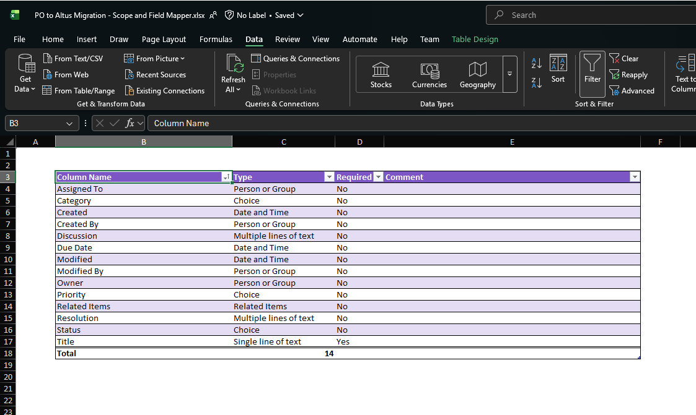

Update Data Validation Settings in Migration Mapping Template
In reference to the [03 - PO to Altus Migration - Scope and Field Mapper.xlsx] template, validate and update data validation ranges across all the blue coloured tabs to ensure the drop-down selection criteria is including the full range of data from the newly loaded tables (yellow tabs):
- Select the entire first column range (Top to bottom) of the blue tab worksheet
- Select Data > Data Validation
- Select the correct range from the appropriate table (Yellow background worksheet tab) - Excluding the table header.
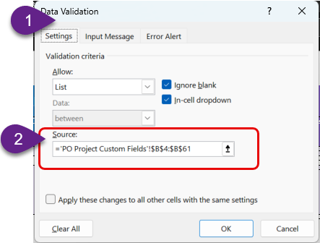
- NOTE, this is a general observation to make throughout this template as data validation list are used through-out most of the template so be aware of this step in case you come across this in other worksheets/tabs. Test the selection options in each tab before handing this template over for the client to complete.

Planning Phase

Planning Phase Steps
ID | Task | Owner | Status | Notes
1 | Facilitate the Project Kick-off meeting. | IC |  | All Data migration project key stakeholders should attend.  Record the session for attendees who cannot make the session plus as evidence of the discussion, questions, decisions and actions from that session.  Use the provided [02 - PO to Altus Migration - Project Kick Off.pptx] template.  This session should be heavily focussed on alignment with the client on what exactly the scope of this engagement is and the client’s role to play in helping us achieve a successful outcome. It also provides opportunity for further questions, clarifications and shared understandings to be aligned.  Make sure you get a good visual walkthrough of what the client is currently doing in Project online. Discuss the things working well, not working well and opportunities for what they would ultimately like their PPM tool to do. Use this information to highlight the value of Altus and transparently point out any fundamental differences to guide ongoing change management activities for the client.  The session will typically run between 2 and 3 hours but you may choose to break some sections of the session into separate sessions. For example:  - Altus Technical Readiness – This step should also be briefly covered but it may require subsequent meetings/screen share sessions with the client technical staff depending on their internal structure and complexity.  - 03 - Migration Scope and Mapping Template – Showcase what the template is and how it works. This artefact is designed to give to the client for them to run their own internal workshop and provide our team with the data mappings and base Altus configurations. Depending on the client, they may likely need assistance filling this in as a separate workshop or a series of Q and A support during the process.  - Altus Product Walkthrough – They key intention of this demonstration is to highlight the key points of difference in Altus to Project Online (Altus Finance Grid, Resource Demand Engine, Altus for Project Desktop Add-in). If the client has already had this in the pre-sales steps, you can ignore this step until the Altus test environment is available, then you can do a guided walkthrough in a later step.
2 | Copy Meeting recording and transcripts to Project Team Site | IC |  | Copy meeting recording and transcript to a meetings folder inside your Project Team Site document library (Shared)  Ensure all project documentation, key communications and project related artefacts are managed centrally from this site.
3 | Send pre-loaded Migration Template to Client for completion directly after the kick-off meeting. | IC |  | Send a link to the pre-loaded Migration Template [03 - Migration Scope and Mapping Template] in the shared project Team Site for the Client to complete.  Organise a separate Meeting to facilitate the client completing this activity. Give focus to completing the Orange and Gray tab worksheets so the TC can complete the base Altus configurations. The Blue tabs can be set as an internal client workshop exercise if there is insufficient time.  Set a realistic date for when that Migration Template is to be completed to avoid delays to the project.
4 | Update Planner Board Key Dates | IC |  | Make any necessary updates to the planner board tasks and planned dates resulting from previous meetings and communications. This will be an ongoing activity for the IC.
5 | Support the Altus Technical Readiness Process | TC |  | Assist and support the Clients IT Administrators in completing the Altus Technical Readiness steps. This can sometimes require multiple meetings with various IT roles and being asked to respond to technical questions and cyber security related questions about the product.  Quick links to the technical readiness steps:  - Altus PPM: Link  - Altus for Project : Link  - Altus for Teams: Link  - Altus for Word: Link
6 | Ensure completion of the Migration Scope and Mapping Template | IC |  | This artefact is designed to give to the client for them to run their own internal workshop and provide our team with the data mappings and base Altus configurations as a homework activity.  Depending on the client, they may likely need assistance filling this in as a separate workshop or a series of Q and A support during the process.
7 | Save Altus deployment account details in Company Password vault | TC |  | Once technical readiness has been completed by the Client, and our deployment account has been setup and provided to the TC, ensure these credentials are saved in your internal secure password vault, along with any client specific URL and login information.
8 | Deploy base Altus product to the clients Development, Test and Production environments | TC |  | Once technical readiness has been completed by the Client, and our deployment account has been setup and provided to the TC:  Deploy Altus into the Dev, Test and Production Environments.  https://docs.altus.pro/products/AltusPPM/Deployment/index.html  Ensure deployment includes the latest Power BI Desktop Reports and Power BI Paginated Status reports.
9 | Create a Power App Solution and Publisher in the Development environment | TC |  | This will be an unmanaged solution in the development environment only, used to capture organisational specific configurations of Altus.  Create a solution named [PartnerName Enhancements].  Create a [PartnerName] publisher and an appropriate prefix unique to that partner. For example, AltusPartnerX Enhancements may use ‘ap’ as the publisher prefix.  This package will be exported in a managed state when exporting out these configurations to the clients Test and Production environments. Only ever export managed solutions for Test and Production.
10 | Grant Access to Client Stakeholders to the Altus environments | TC |  | Provide early access to the Clients identified key stakeholders to grant access to the clients Altus test environment in preparation of the upcoming guided Altus walkthrough session.
11 | Configure Base Altus Settings across all 3 environments | TC |  | Align all 3 Altus environments with the Base settings outlined in the 03 - Migration Scope and Mapping Template. Configure the following items (Hold CTRL+Left Click to jump directly to the detailed steps of each item):  - Configure Financial Category Values  - Update Altus Department Values  - Configure Project Type Stage Gate Names and Order  - Configure Enterprise Project Type Settings  - Configure Fiscal Periods  - Configure Global Resource Calendars  - Configure Security Mapping to out of the box Altus roles  - Configure Risk Matrix
12 | Organise and facilitate an Altus walkthrough of the clients Test environment | Lead by IC  Supported by TC |  | Purpose of this step is to provide a guided walkthrough with the client to navigate their new Altus Test environment where they can create a new project and get an interactive first account of how Altus will operate for them internally.  Ensure users can login and access initially. Get them creating a new project, connecting a Project MPP file, explain how the resourcing engine works in Altus and showcase the out of the box Project insights reporting.
13 | Send the Training Agendas and the Client Post Migration Checklist Documents. | IC |  | Send the links to the Training Agendas and the Client Post Migration Checklist Documents in the shared project team site to the client.  NOTE, this may require another alignment session to provide further clarity on expectations, particularly if the client needs some further guidance on how to execute the post migration checklist items. Consider a recorded video for each item to make this more scalable across multiple clients.

Planning Phase Helper Guides

Configure Financial Category Values
- Under the Altus Settings menu, click Financial Categories.
- Add new values or edit existing values to align to the information set by the client in the Migration Template [03 - Migration Scope and Mapping Template] in the shared project Team Site. It is the Worksheet tab named [Categories - Departments], located in the first table – Financial Categories.
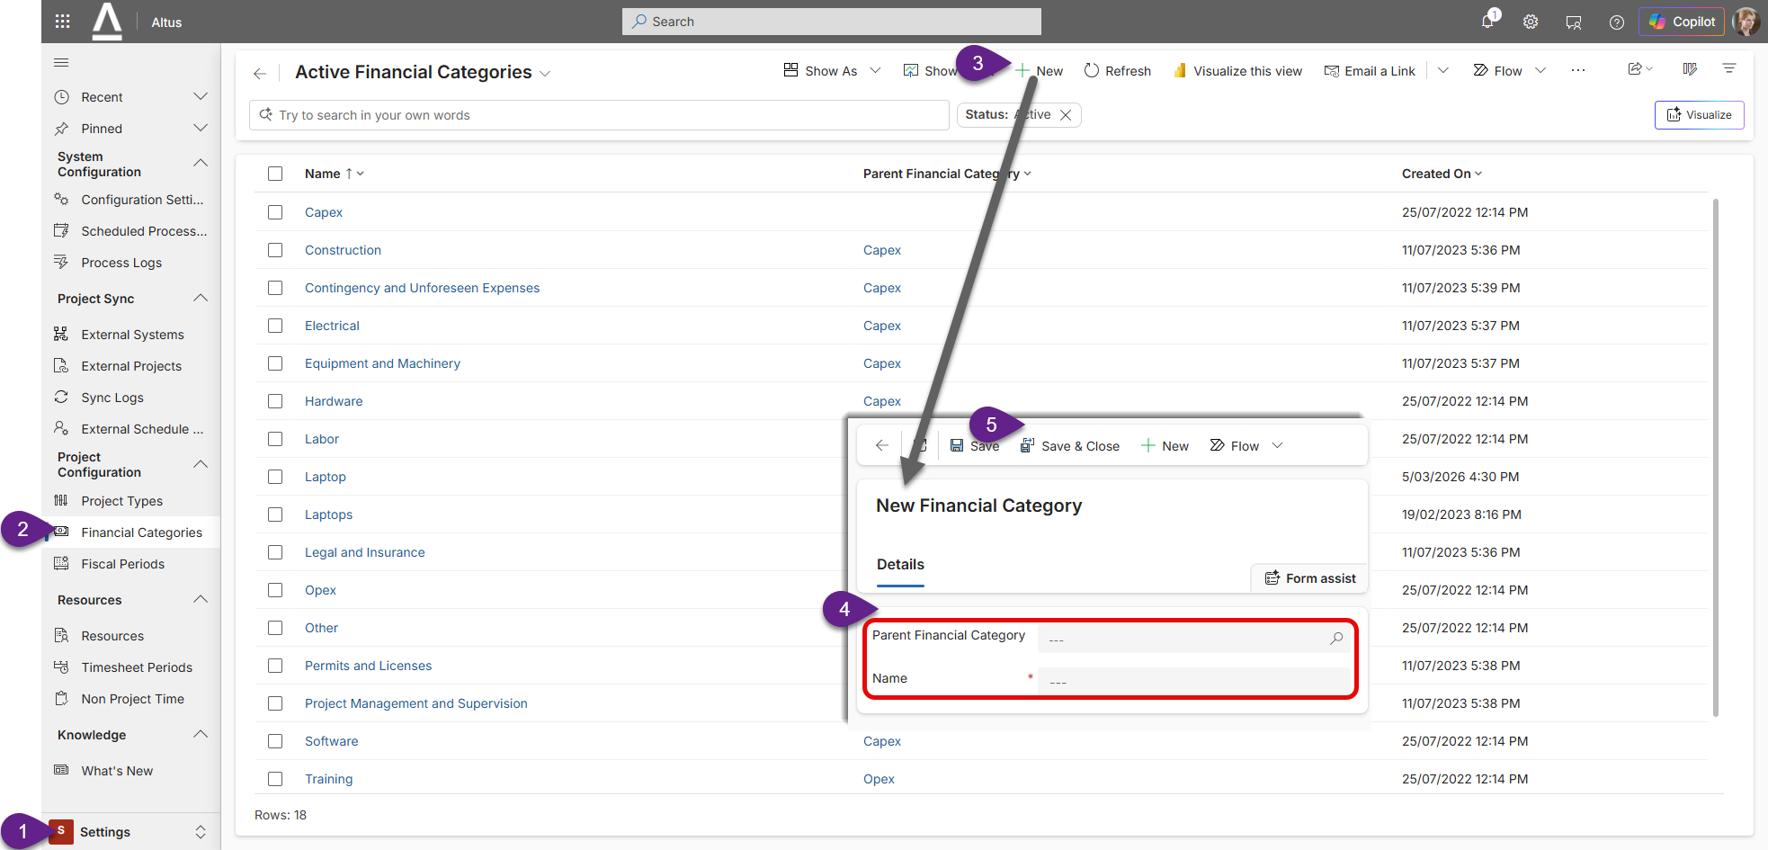

Update Altus Department Values
Altus Department values will need to be updated by the TC via the Power App solution.
It will be a combination of existing Choice lists from specific tables and global choice lists that will need to be added into the unmanaged solution initially in the development environment.
- Add in the following global choice lists to your solution. Add Existing > More > Choice.
  - 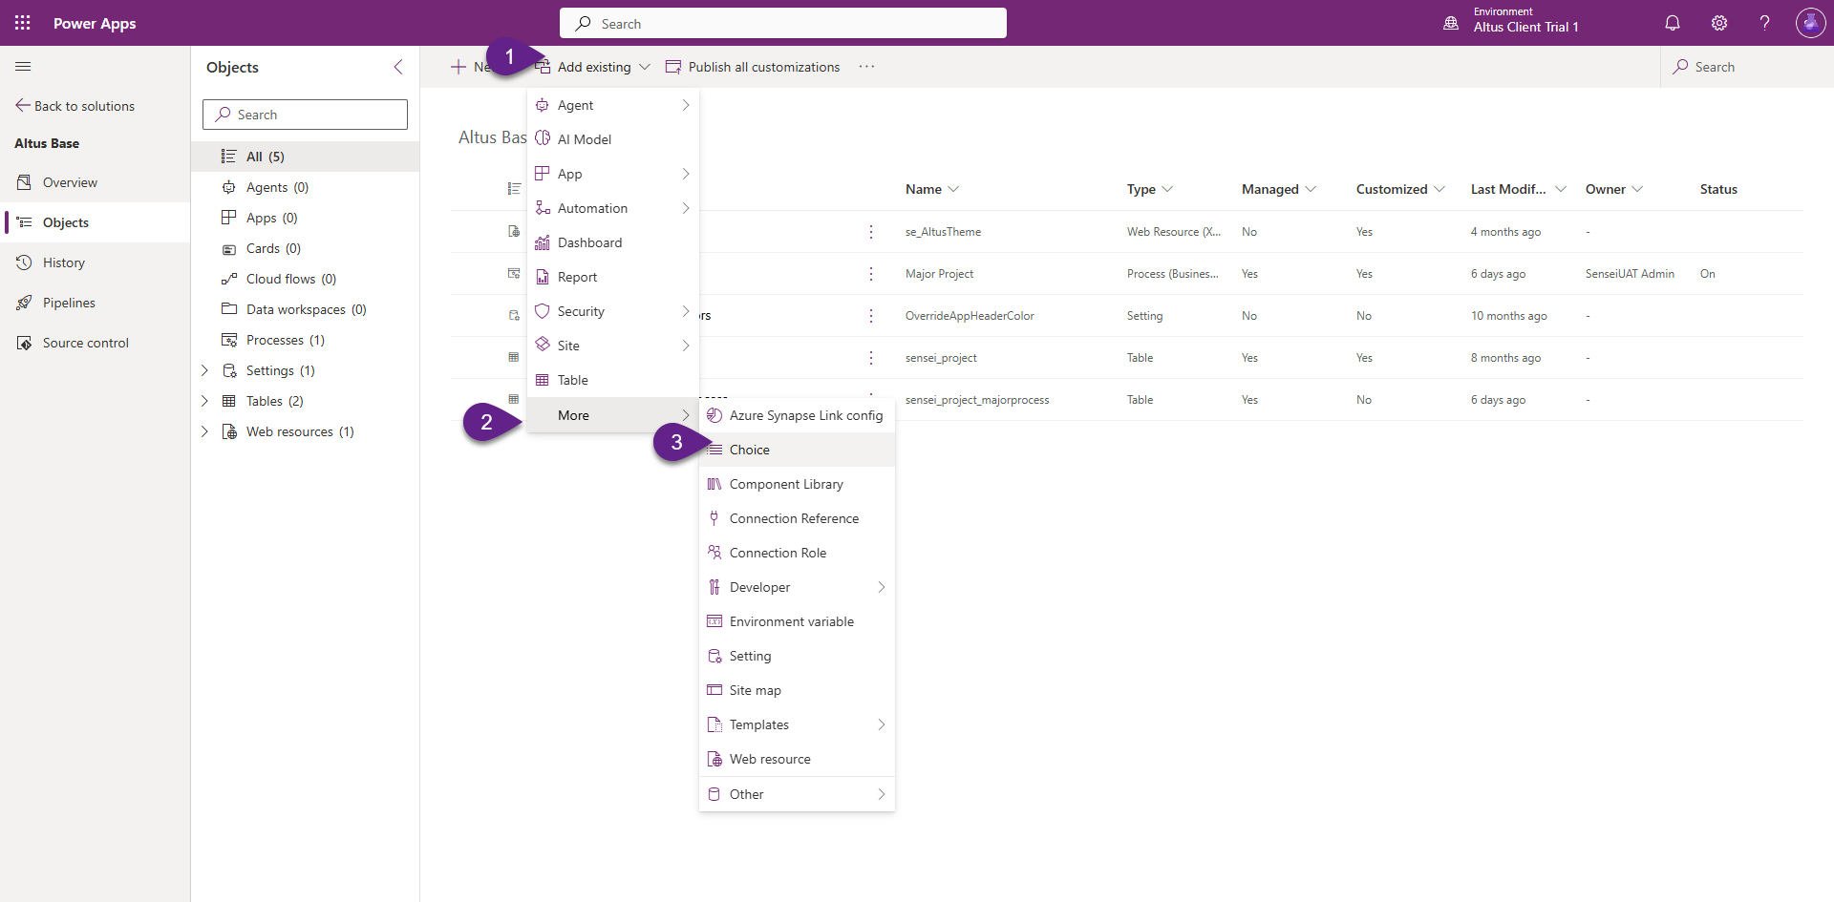
- Search for “Department” and select all 4 options in the results as shown below. Select all and Click Add to add them to your solution
  - 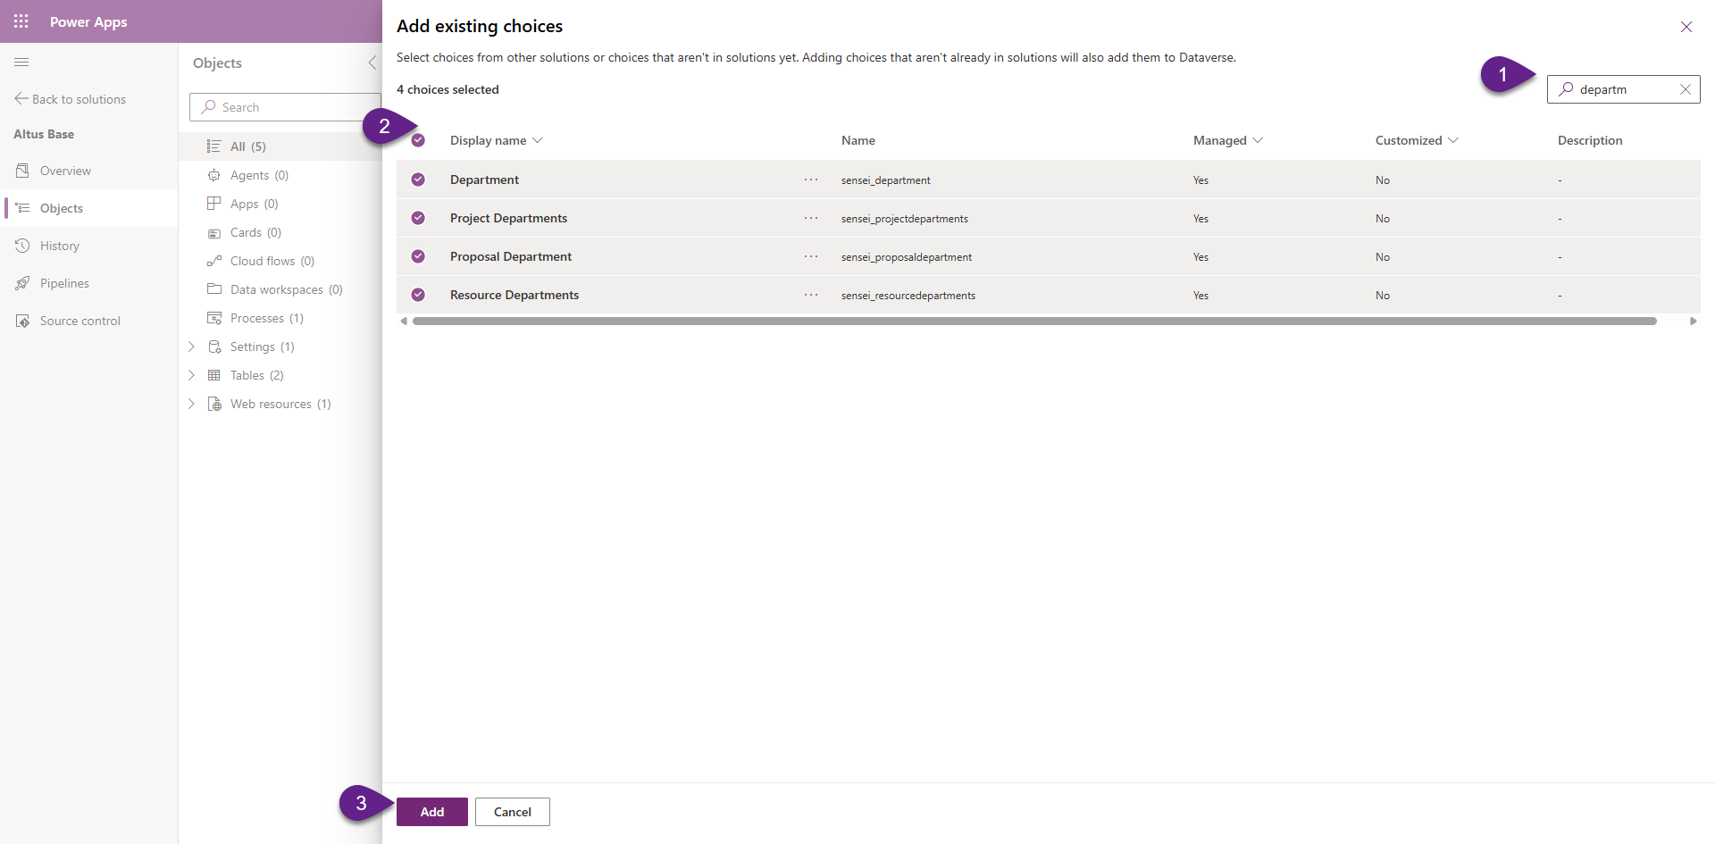
- Click on each choice item to align to the information set by the client in the Migration Template [03 - Migration Scope and Mapping Template] in the shared project Team Site. It is the Worksheet tab named [Categories - Departments], located in the second table – Department.
  - 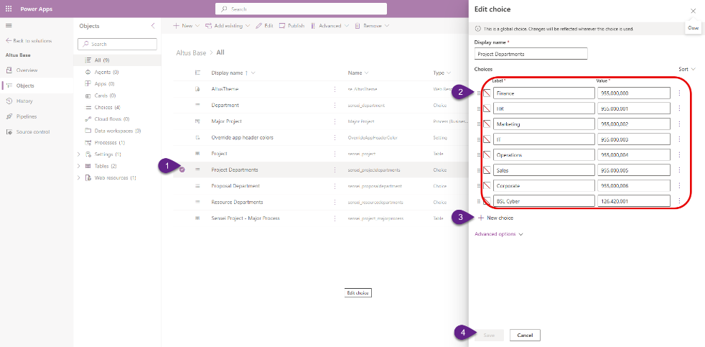
- Remember to save a publish your changes.
- Department is a field that is referenced in the following Altus tables. Check each table to see if your updated Department values have published successfully. Hold CTRL + F5 to force the browser to download the latest version. Any mis-aligned values may be because those tables have an embedded choice field unique to that table. If that is the case, add in the table to your solution, add the existing table column and edit that choice column directly in the table.
  - Projects
  - Programs
  - Portfolios
  - Benefits
  - Resources
  - Proposals
  - Challenges
  - Ideas
  - Financial Items
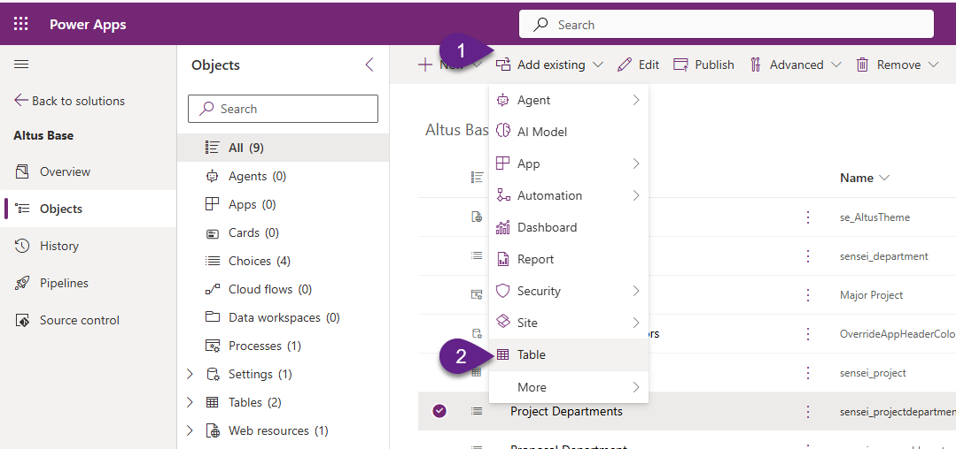

Configure Project Type Stage Gate Names and Order
The TC will need to configure the required Project Stage Gate names within the unmanaged Power App solution using the values specified in the Migration Template [03 - Migration Scope and Mapping Template] in the shared project Team Site. It is the Worksheet tab named [Project Types], located in the first table – Project Stage Gate Names.
- Ideally use the existing Altus project stage gate processes as they have security configured within the base permission model. There are three Project process available out of the box that you can modify.
  - Major Project
  - Minor Project
  - Agile Project
- Add Existing > Automation> Process.
  - 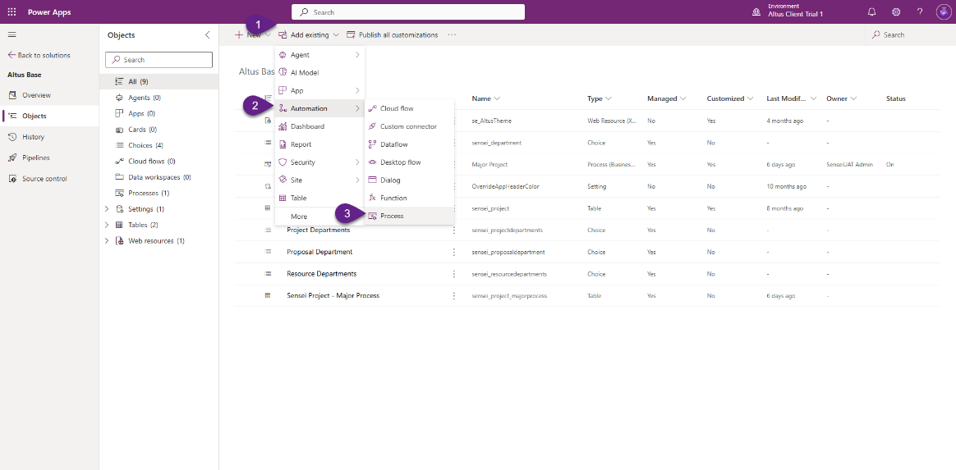
- Search for “Project” and select one or all three project process options in the results as shown. Select all and Click Add to add them to your solution.
  - 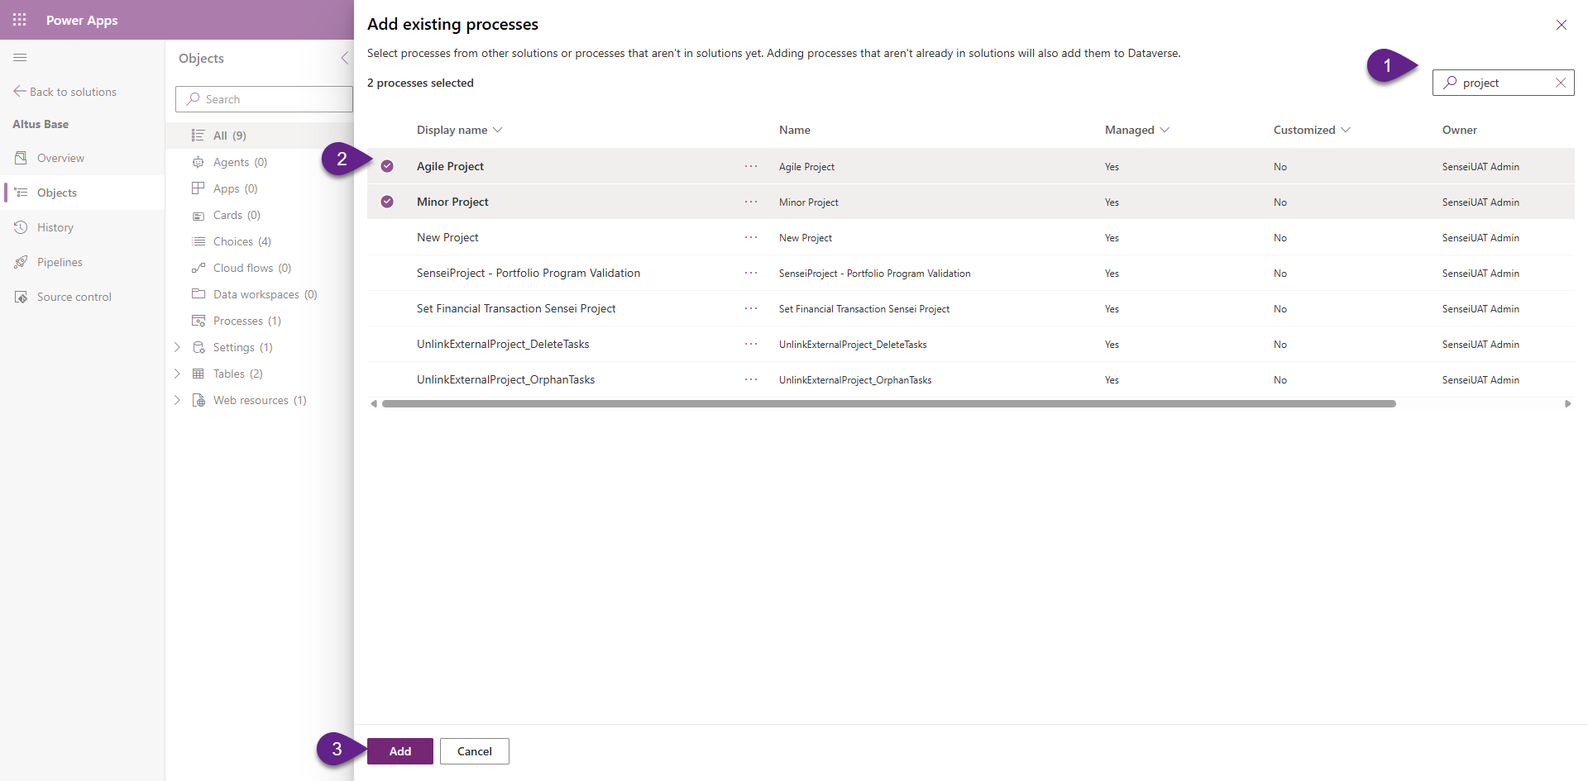
- In the Power App solution, click on the name of the process you want to edit to open up the Process Designer.
  - Drag new Stage items from the component’s toolbox on the right side by left clicking and dragging them onto the design surface in the correct order you require.
    - 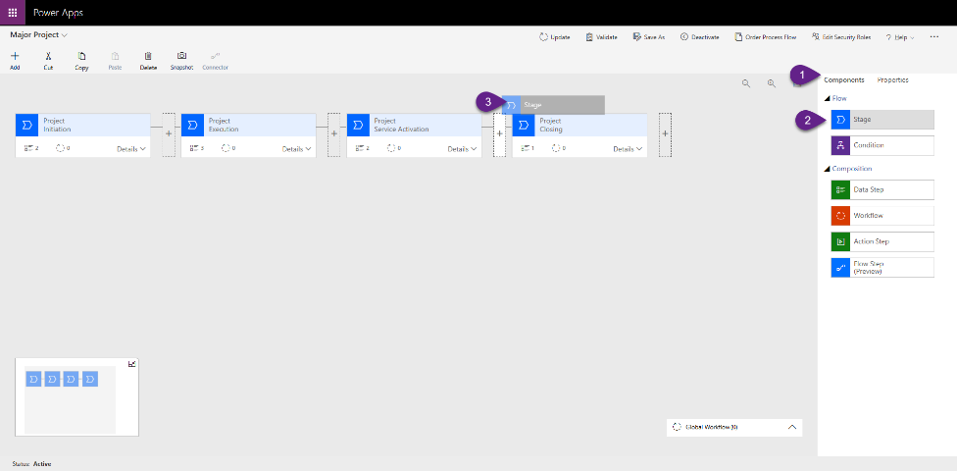
  - Click on a Stage component to edit the Display Name field and click the Apply button each time you make an edit.
    - 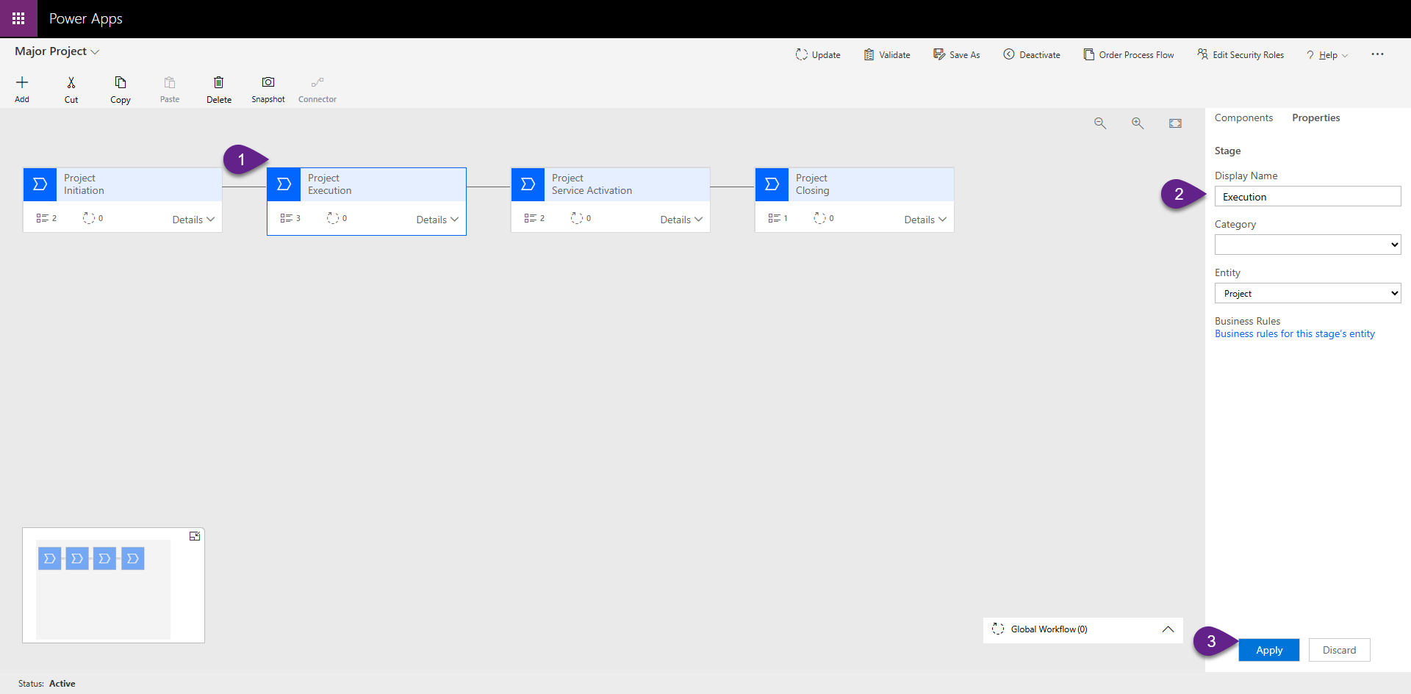
  - Each new project stage component will need a minimum of 1 field shown (Data Step).Set this to the Project Manager.
    - 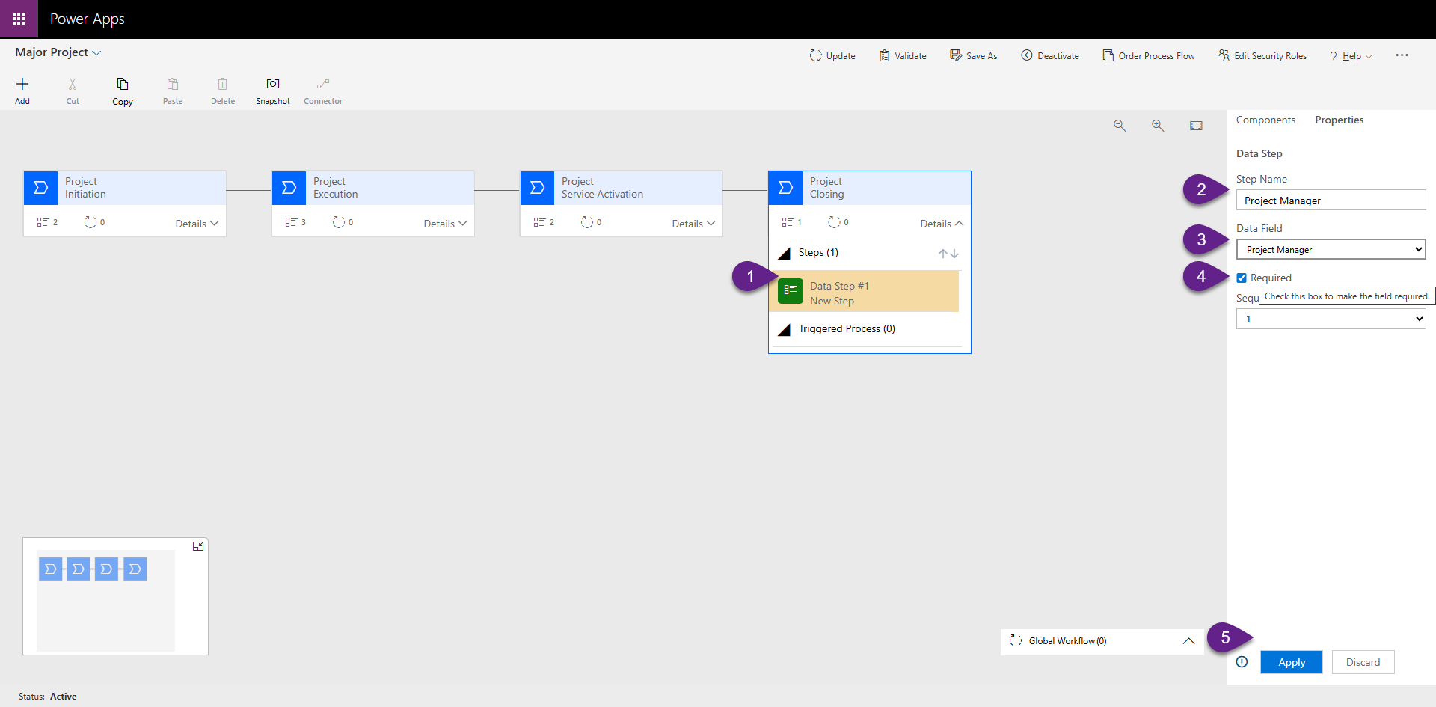
  - Click update, if an existing process to save your changes. If this is a new process, you will need to save and activate it using the menu bar across the top.
- NOTE: If you require more than three processes, you can instead add a new process to the solution, but you will also need to add a new security roll which is granted permissions to the custom processes. This role will then need to be added to all the appropriate out of the box security mappings as an additional step.
  - 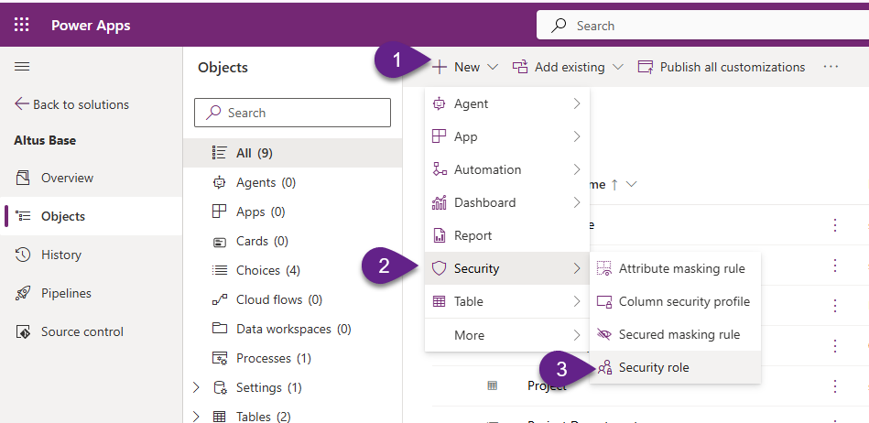
  - Name the group and associate to the business unit
  - 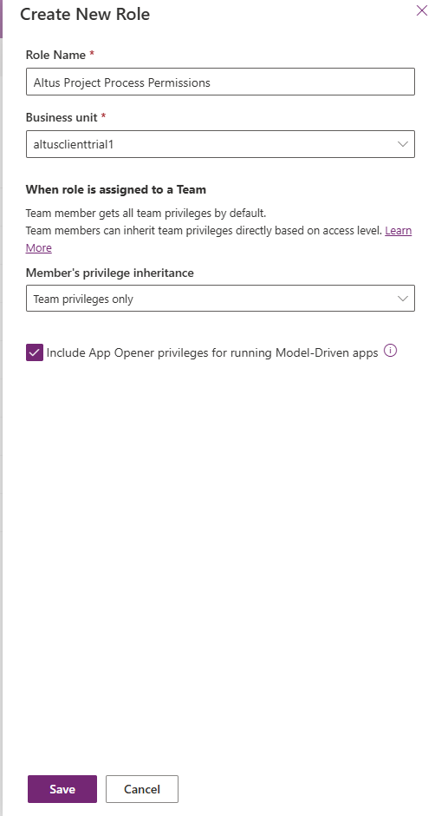
  - Set permissions on the new process
  - 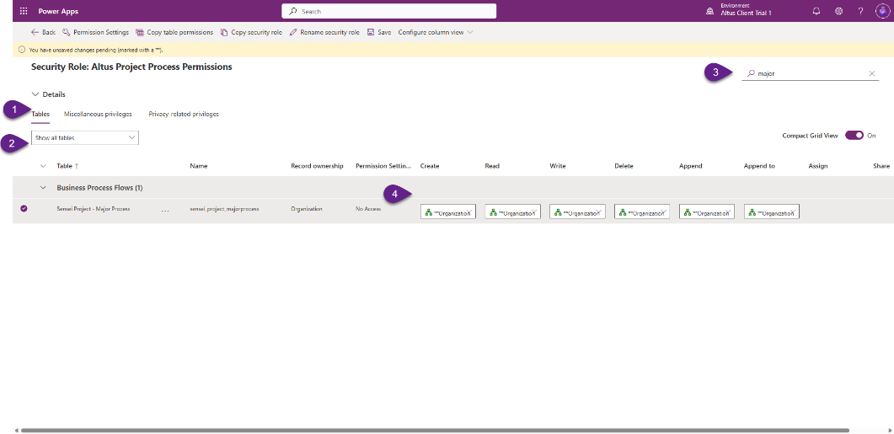

Configure Enterprise Project Type Settings
- Navigate to Altus Settings>Project Types
- Edit existing project types, adding new ones where required and align the settings to the values specified in the Migration Template [03 - Migration Scope and Mapping Template] in the shared project Team Site. It is the Worksheet tab named [Project Types], located in the second table – Project Type Definition and Settings.
  - 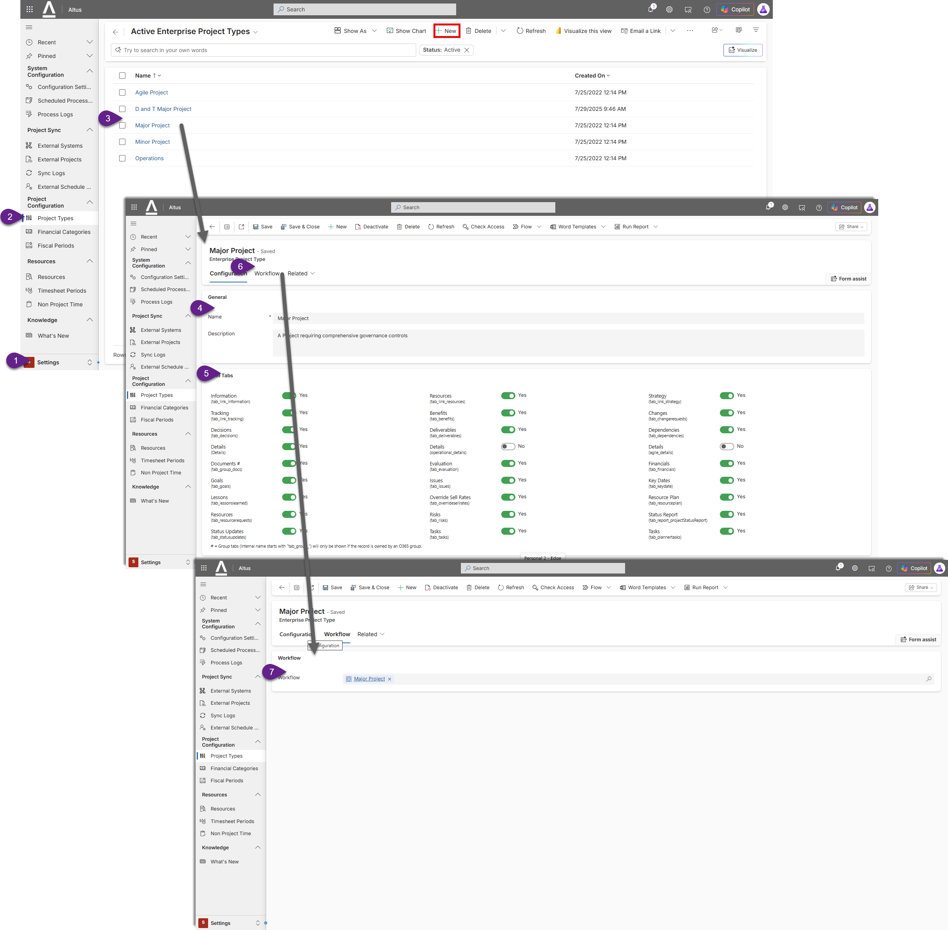

Configure Fiscal Periods
- Navigate to Altus Settings>Fiscal Periods
- Use the Bulk Create button to add new fiscal periods to align the settings specified in the Migration Template [03 - Migration Scope and Mapping Template] in the shared project Team Site. It is the Worksheet tab named [Fiscal Period], noting the value setting for ‘Selected Altus Fiscal Period Method’ and the number of fiscal periods to initially provision.
- 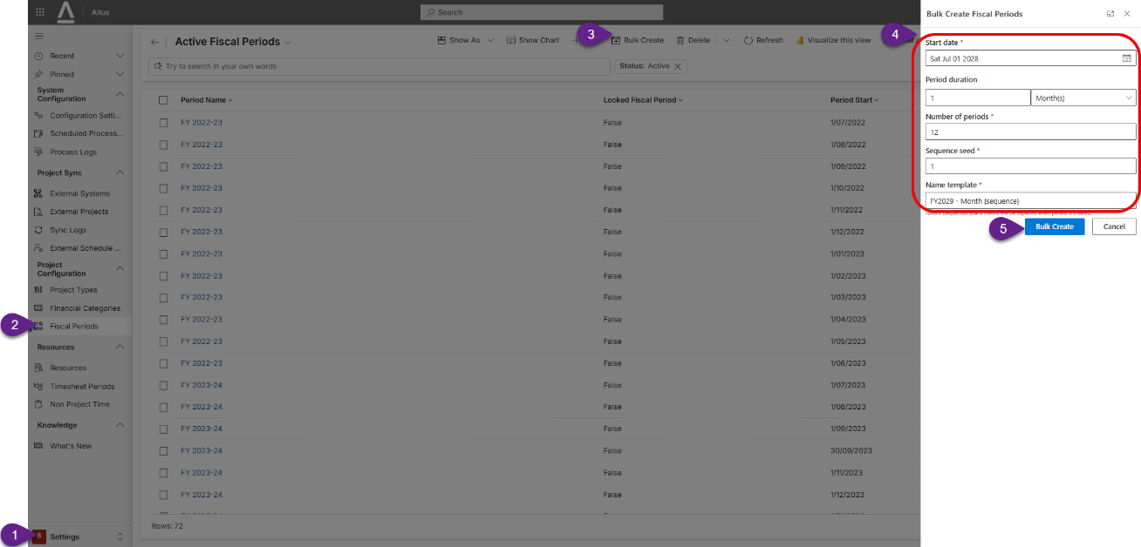
- Further information can be found under the following link: https://docs.altus.pro/products/AltusPPM/AsBuilt/Settings/Project-Configuration.html?q=fiscal%20period#fiscal-periods

Configure Global Resource Calendars
- Navigate to Altus Resources>Enterprise Calendars
- Edit existing global resource calendars, adding new ones where required and align the settings to the values specified in the Migration Template [03 - Migration Scope and Mapping Template] in the shared project Team Site. It is the Worksheet tab named [Global Calendars], located in the first table – Global Resource Calendars.
  - 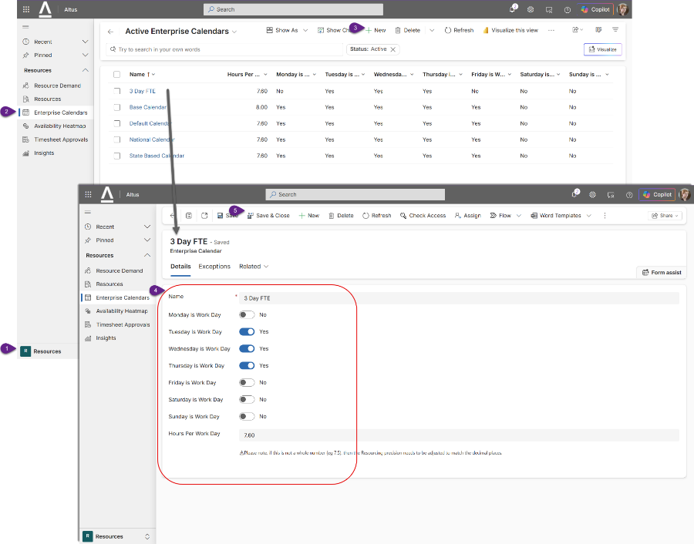

Configure Security Mapping to out of the box Altus roles
Altus Security role mapping is done through the Microsoft Power App Admin Portal.
- Navigate to Manage Environments in the Power App Admin Portal
  - https://admin.powerplatform.microsoft.com/manage/environments
- Click on an Altus environment to update.
- Click Settings
- Under Users + permissions, select Teams
- Click Create Team to add new teams based on the out of the box mappings indicated in the Migration Template [03 - Migration Scope and Mapping Template] in the shared project Team Site. It is the Worksheet tab named [Security Mapping], located in the first table – Client Entra ID/AAD Groups for Altus.
  - 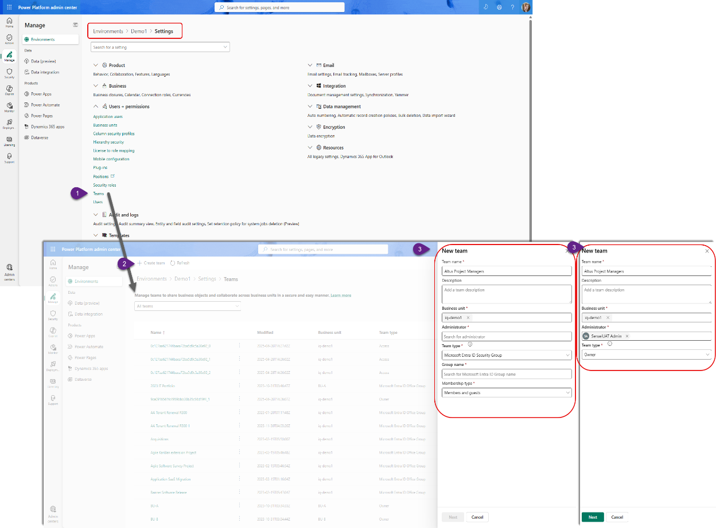
- If not mapped to a AAD group (Owner Team), complete the user mapping as indicated in the second table named User Membership Assignment.

Configure Risk Matrix
- Navigate to Altus Settings>Configuration>Risk Matrix (NOTE: this will need to be replicated for Project, Program and Portfolio Risk Matrix settings.
  - 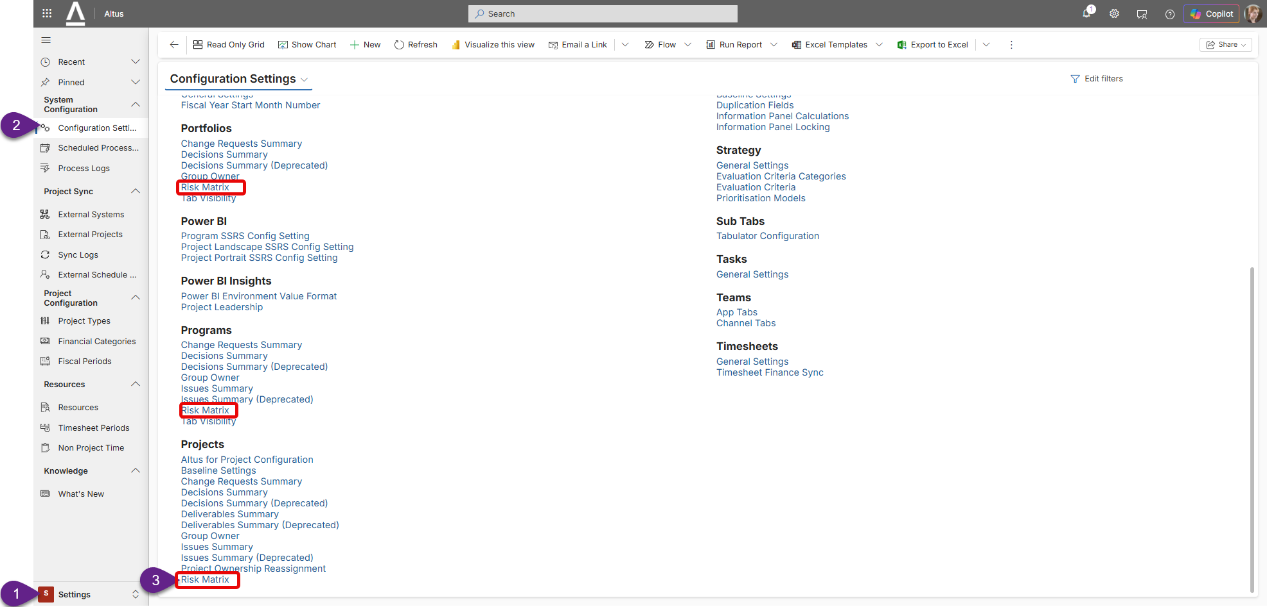
- Edit existing project types, adding new ones where required and align the settings to the values specified in the Migration Template [03 - Migration Scope and Mapping Template] in the shared project Team Site. It is the Worksheet tab named [Risks], located in the second table, below the risk schema table and to the right – Risk Matrix likelihood and consequence grid.
  - 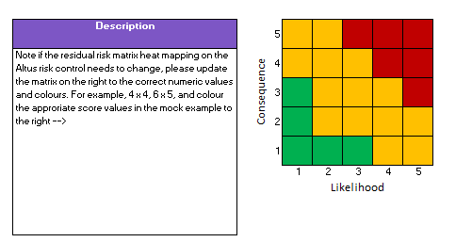
- Please refer to the steps outlined on the Altus technical documentation site on how to configure this control as per the client’s requirements:
  - https://docs.altus.pro/products/AltusPPM/Configuration/Work/index.html

Migration Phase

Migration Phase Steps
ID | Task | Owner | Status | Notes
1 | Align Altus Projects Table to client configuration | TC |  | Using the Managed Altus solution in the development environment, add the Project table (sensei_project) to your solution. Do not include all objects or table metadata (un-ticked)  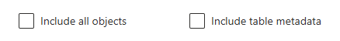  Add/update the following areas to align with the information specified in the ‘Projects – Details’ worksheet of the Migration Template [03 - Migration Scope and Mapping Template] in the shared project Team Site.  - Columns  - Add new columns as placeholder fields for the migration process to map to  - Add existing columns to the solution to change existing Altus field names/settings.  - Add required Project Formula custom fields as new fields. You will need to translate the formula logic from Project Online’s Excel-like formula syntax to the Power Apps platform calculated field language, PowerFX. We recommend using a modern AI tool like Microsoft Copilot, Claude, ChatGPT to assist with that translation. Note these will need to be tested by the client thoroughly.  - Views  - Add the existing ‘All Active Projects’ view to your solution  - Click on the view to edit the view columns and settings.  - Forms  - Add the existing Information (Main) form to your solution  - Click on the form name to make updates to this form  - NOTE: By default, the project form tabs are hidden to run the Project Type register settings. Click on the Show hidden slider on and add/modify your project custom fields to the first details tab of the form.  - 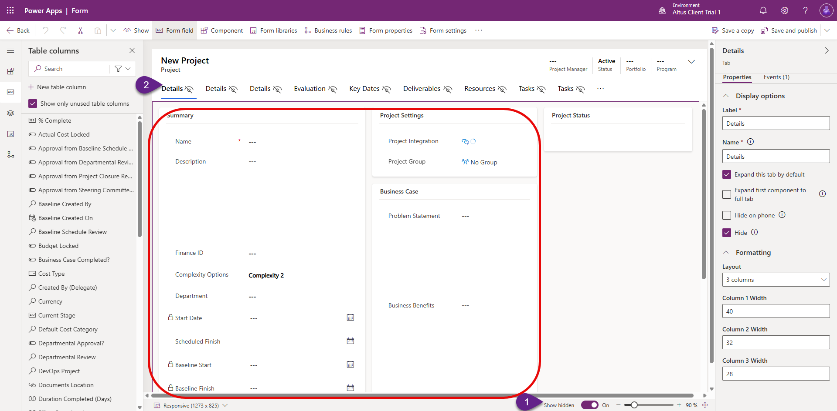  - Add the existing form named ‘quick create form’ to your solution.  - Click on the form name to make updates to this form  - Save and publish all changes in the solution.
2 | Align Altus Task Table to client configuration | TC |  | Using the Managed Altus solution in the development environment, add the Project Task table (sensei_task) to your solution. Do not include all objects or table metadata (un-ticked)  Add/update the following areas to align with the information specified in the ‘Tasks’ worksheet of the Migration Template [03 - Migration Scope and Mapping Template] in the shared project Team Site.  - Columns  - Add new columns as placeholder fields for the migration process to map to  - Add existing columns to the solution to change existing Altus field names/settings.  - Add required Task Formula custom fields as new fields. You will need to translate the formula logic from Project Online’s Excel-like formula syntax to the Power Apps platform calculated field language, PowerFX. We recommend using a modern AI tool like Microsoft Copilot, Claude, ChatGPT to assist with that translation. Note these will need to be tested thoroughly.  - Views  - Add the existing ‘All Project Tasks’ view to your solution  - Click on the view to edit the view columns and settings.  - Save and publish all changes in the solution.
3 | Align Altus Resources (Bookable Resource) Table to client configuration | TC |  | Using the Managed Altus solution in the development environment, add the Bookable Resource table (sensei_bookableresource) to your solution. Do not include all objects or table metadata (un-ticked)  Add/update the following areas to align with the information specified in the ‘Resources’ worksheet of the Migration Template [03 - Migration Scope and Mapping Template] in the shared project Team Site.  - Columns  - Add new columns as placeholder fields for the migration process to map to  - Add existing columns to the solution to change existing Altus field names/settings.  - Add required Resource Formula custom fields as new fields. You will need to translate the formula logic from Project Online’s Excel-like formula syntax to the Power Apps platform calculated field language, PowerFX. We recommend using a modern AI tool like Microsoft Copilot, Claude, ChatGPT to assist with that translation. Note these will need to be tested by the client thoroughly.  - Views  - Add the existing ‘Active Bookable Resources’ view to your solution  - Click on the view to edit the view columns and settings.  - Forms  - Add the existing Information (Main) form to your solution  - Click on the form name to make updates to this form  - 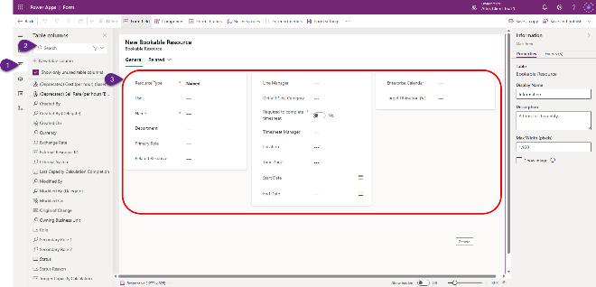  - Save and publish all changes in the solution.
4 | Align Altus Issues to client configuration | TC |  | Using the Managed Altus solution in the development environment, add the Issue table (sensei_issue) to your solution. Do not include all objects or table metadata (un-ticked)  Add/update the following areas to align with the information specified in the ‘Issues’ worksheet of the Migration Template [03 - Migration Scope and Mapping Template] in the shared project Team Site.  - Columns  - Add new columns as placeholder fields for the migration process to map to.  - Add existing columns to the solution to change existing Altus field names/settings.  - Add required Issue Formula custom fields as new fields. You will need to translate the formula logic from Project Online’s Excel-like formula syntax to the Power Apps platform calculated field language, PowerFX. We recommend using a modern AI tool like Microsoft Copilot, Claude, ChatGPT to assist with that translation. Note these will need to be tested by the client thoroughly.  - Views  - Add the existing ‘Project Issues’ view to your solution  - Click on the view to edit the view columns and settings.  - Forms  - Add the existing ‘Main – Altus’ (Main) form to your solution  - Click on the form name to make updates to this form  - 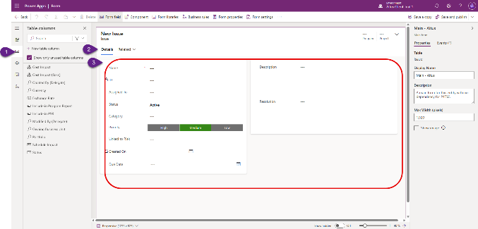  - Add the existing form named ‘Information’ (Quick View Form) to your solution.  - Click on the form name to make updates to this form  - Save and publish all changes in the solution.
5 | Align Altus Risks Table to client configuration | TC |  | Using the Managed Altus solution in the development environment, add the Risk table (sensei_risk) to your solution. Do not include all objects or table metadata (un-ticked)  Add/update the following areas to align with the information specified in the ‘Risks’ worksheet of the Migration Template [03 - Migration Scope and Mapping Template] in the shared project Team Site.  - Columns  - Add new columns as placeholder fields for the migration process to map to.  - Add existing columns to the solution to change existing Altus field names/settings.  - Add required Risk Formula custom fields as new fields. You will need to translate the formula logic from Project Online’s Excel-like formula syntax to the Power Apps platform calculated field language, PowerFX. We recommend using a modern AI tool like Microsoft Copilot, Claude, ChatGPT to assist with that translation. Note these will need to be tested by the client thoroughly.  - Views  - Add the existing ‘Project Risks’ view to your solution  - Click on the view to edit the view columns and settings.  - Forms  - Add the existing ‘Main – Altus’ (Main) form to your solution  - Click on the form name to make updates to this form  - 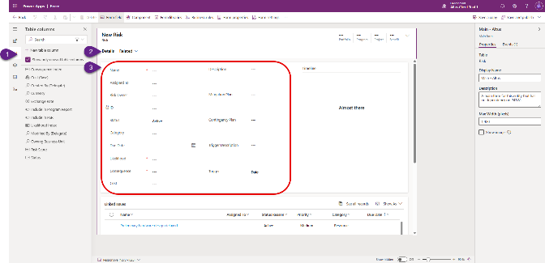  - Add the existing form named ‘Information’ (Quick View Form) to your solution.  - Click on the form name to make updates to this form  - Save and publish all changes in the solution.
6 | Push configuration changes solution (managed) to Test and Production environments | TC |  | - From the Power Apps maker area: https://make.powerapps.com/  - Select the Altus Development environment from the selector in the top right section of the screen. Select Solutions. Select the name of your Altus configuration solution and then click the Export Solution option in the top menu bar  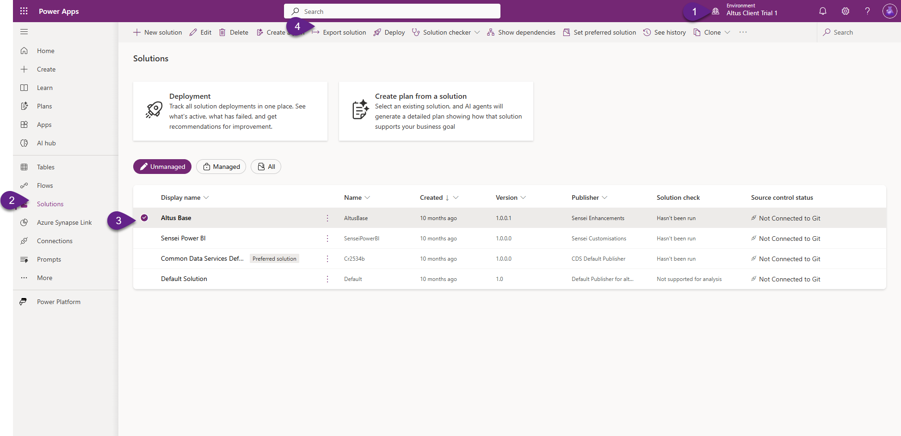  - The wizard will prompt you to publish, feel free if not already done so. Click next.  - Click Next through the managed dependencies screen.  - The version number will automatically increment from the current version. Ensure the ‘Managed’ option is selected as our test and production environments should only ever have managed solution versions of this package. Click export.  - This process may take a few minutes but the notification bar at the top of the browser will let you know when it is ready to download.  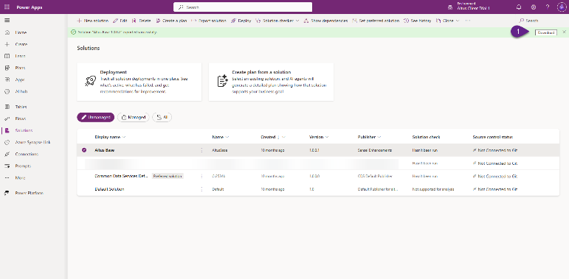  - Store a copy of this solution export file into the shared project site as a backup.  - Also run through the process again and export an unmanaged version, noting to keep the same version number consistent.
7 | Update the Altus for Project Task Mappings | TC |  | Apply these same steps for all Altus environments (Development, Test, Production)  - Navigate to Altus>Settings>Configuration Settings.  - Under the Project heading, click on ‘Altus for Project Configuration’.  - Add any local task custom fields from the Project Desktop application to the mapped field placeholder in the Altus Task (sensei_task) table as per the steps described here: https://docs.altus.pro/products/AltusForProject/Configuration.html#microsoft-project-to-altus-field-mapping  - NOTE: this is only for project task custom fields. A reportable (Yes/No) Task custom field for example may use the agreed local field slot of Text1 or OutlineCode1 for example to retain its data within the Project Desktop file so in the Altus configuration we add a new Custom Field Mapping  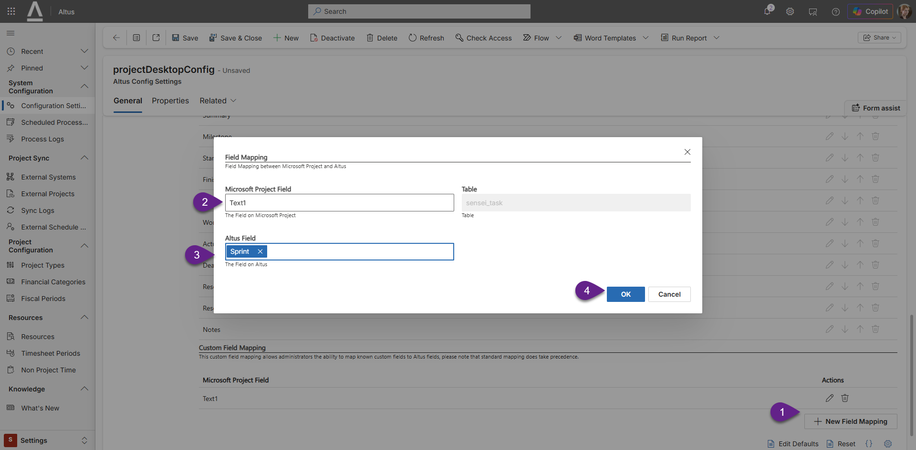
8 | Download migration script pack to local machine | TC |  | Download the latest version of the Altus to Project Online Migration Toolkit from the Altus Partner Portal to your local machine. Altus.Project.Online.Migration.Toolkit.2026.05.26.1.zip
9 | Prepare Project Online Custom Fields for Extraction (Removing special characters) | TC |  | Review all Project, Task and Custom fields from Project Online to ensure no fields contain any non-alphabetical or numerical characters. Apostrophes or commas for example. The Microsoft API wont handle this and cause an error to this step will require you identify and document any fields that fall under this category. We will need to manually remove those characters from the fields in Project Online under PWA>Server Settings>Enterprise Custom Fields and Lookups. Before doing this step, coordinate with the business any outage window required as reports and queries for example will break. Once the migration extraction is complete, they can be renamed to the previous name but ensure you document the original names before commencing this step.
10 | Prepare Migration Scripts | TC |  | Align the Migration scripts settings and parameters to the mapped fields (Project Online > Altus) specified in the Migration Template [03 - Migration Scope and Mapping Template] in the shared project Team Site.  Specifically, this will be regarding the blue worksheet tabs:  - Project – Details Tab  - Tasks  - Resources  - Issues  - Risks  Have these settings ready to use when running the [04 - Data Migration Script Pack User Guide.docx] in the next step.
11 | Execute steps as per the [04 - Data Migration Script Pack User Guide.docx] | TC |  | Below is a summary of the key steps that need to be performed but please follow the steps outlined in the following document: [04 - Data Migration Script Pack User Guide.docx]  - Run Data Migration toolkit pre-requisites  - Extract Data from Project Online  - Download Projects, Schedules, Custom Fields and Resources from Project Online  - Download Lookup Tables  - Download Project Documents  - Migrate Data into Altus  - Create Lookup Tables in Altus  - Create Resources in Altus  - Create Projects in Altus  - Migrate Project Financials  - Migrate Schedules into altus and update Resource Rates  - Documentation Migration
12 | Conduct Post Migration Steps (Internal) | TC |  | Once migration has successfully completed, manually step through the post migration steps that need to be performed internally as per the following section ‘Post Migration Checklist (Internal)’.
13 | Notify client they may commence their Post Migration Steps | TC |  | Alert the client via the team site and email when they are cleared to commence their post migration steps.  Send a link to the Client Post Migration Steps document in the share Microsoft Team site.  For reference, post migration checklist steps for the client are also located in this document under the following section: ‘Post Migration Checklist (Client)’.
14 | Client to Conduct Post Migration Steps (Client) | IPM |  | Please refer to the ‘Post Migration Checklist (Client)’ section on further details of the post migration steps the client will need to complete.
15 | Validate and Test the success of the Data Migration | All project stakeholders |  | Validate and Test the success of the Data Migration through manual spot testing. Report any issues to the implementation team via the issues list within the shared Project Team site.

Migration Phase Helper Guides

Post Migration Checklist (Internal)
<JP Completing this step>

Post Migration Checklist (Client)
Refer to the steps outlined in the Project Online to Altus Document titled [05 - Post Migration Checklist - Client.docx].

Training Phase

Training Phase Steps
ID | Task | Owner | Status | Notes
1 | Schedule Training Sessions with Client | IC |  | Ideally get the client to setup the Meeting invites for all three sessions (Administrator, Project Manager, Team Members). This way they include manage the invite membership and choose to keep the recording to share with other internal staff.
2 | Conduct Training | IC |  | Using the training agenda provided in the migration documentation pack as your guide, conduct the end user training.  Review the agenda and ensure the topics are still relevant to this client’s particular migration scenario.  Make notes of your estimated timings for each key section  Perform a dry-run-through to make sure you are comfortable with the timing. Allow for introductions, questions and wrap-up time to track where you are throughout the session.  High engagement and questions could be left in a car-park type facility. Use chat for example to capture them and later go back to collect and respond to them if needed. Ideally have someone like the ITC responding to these during the session. Recommend this approach for large volume participants.
3 | Copy Recording and Transcript to the Shared Team Site | IC/IPM |  | Coordinate with the clients Project Manager (IPM) to store a copy of the recorded training sessions and their transcripts in the shared Project Team Site for safe-keeping and future reference.

Training Phase Helper Guides

Administrator Training Agenda
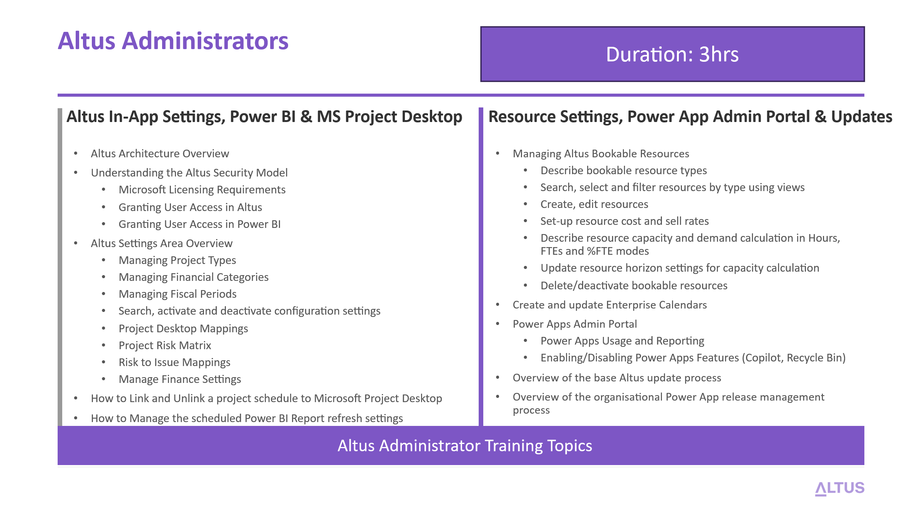
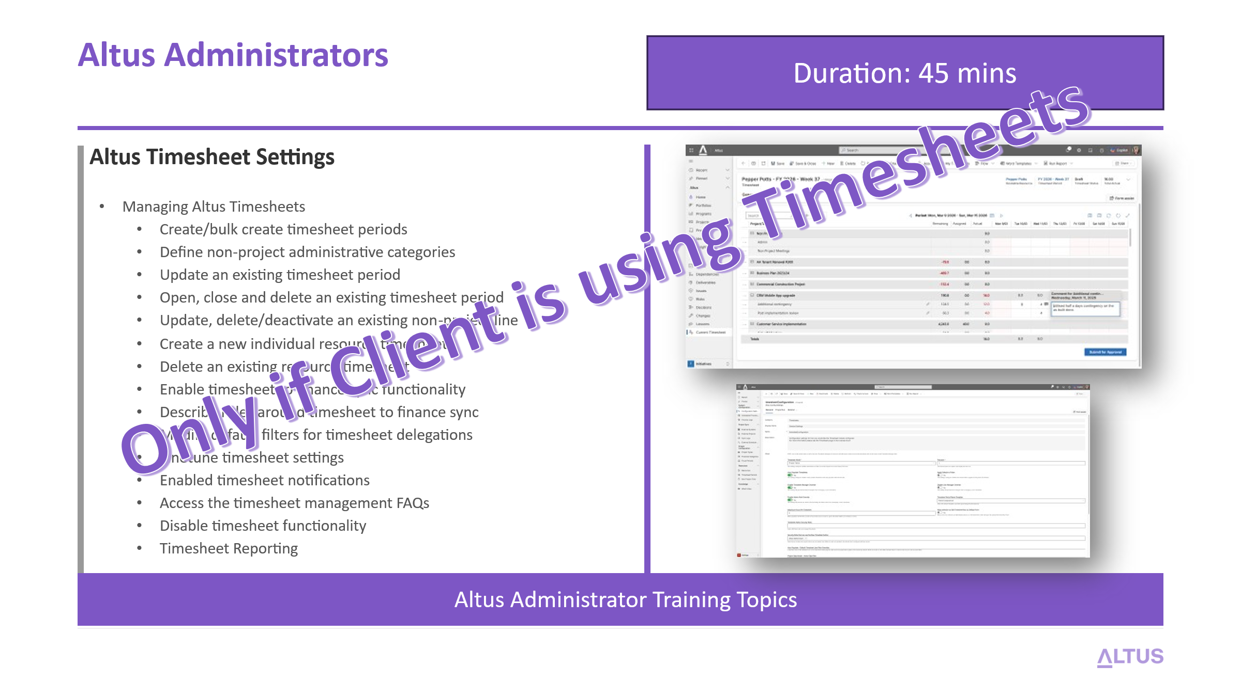

Project Manager Training Agenda
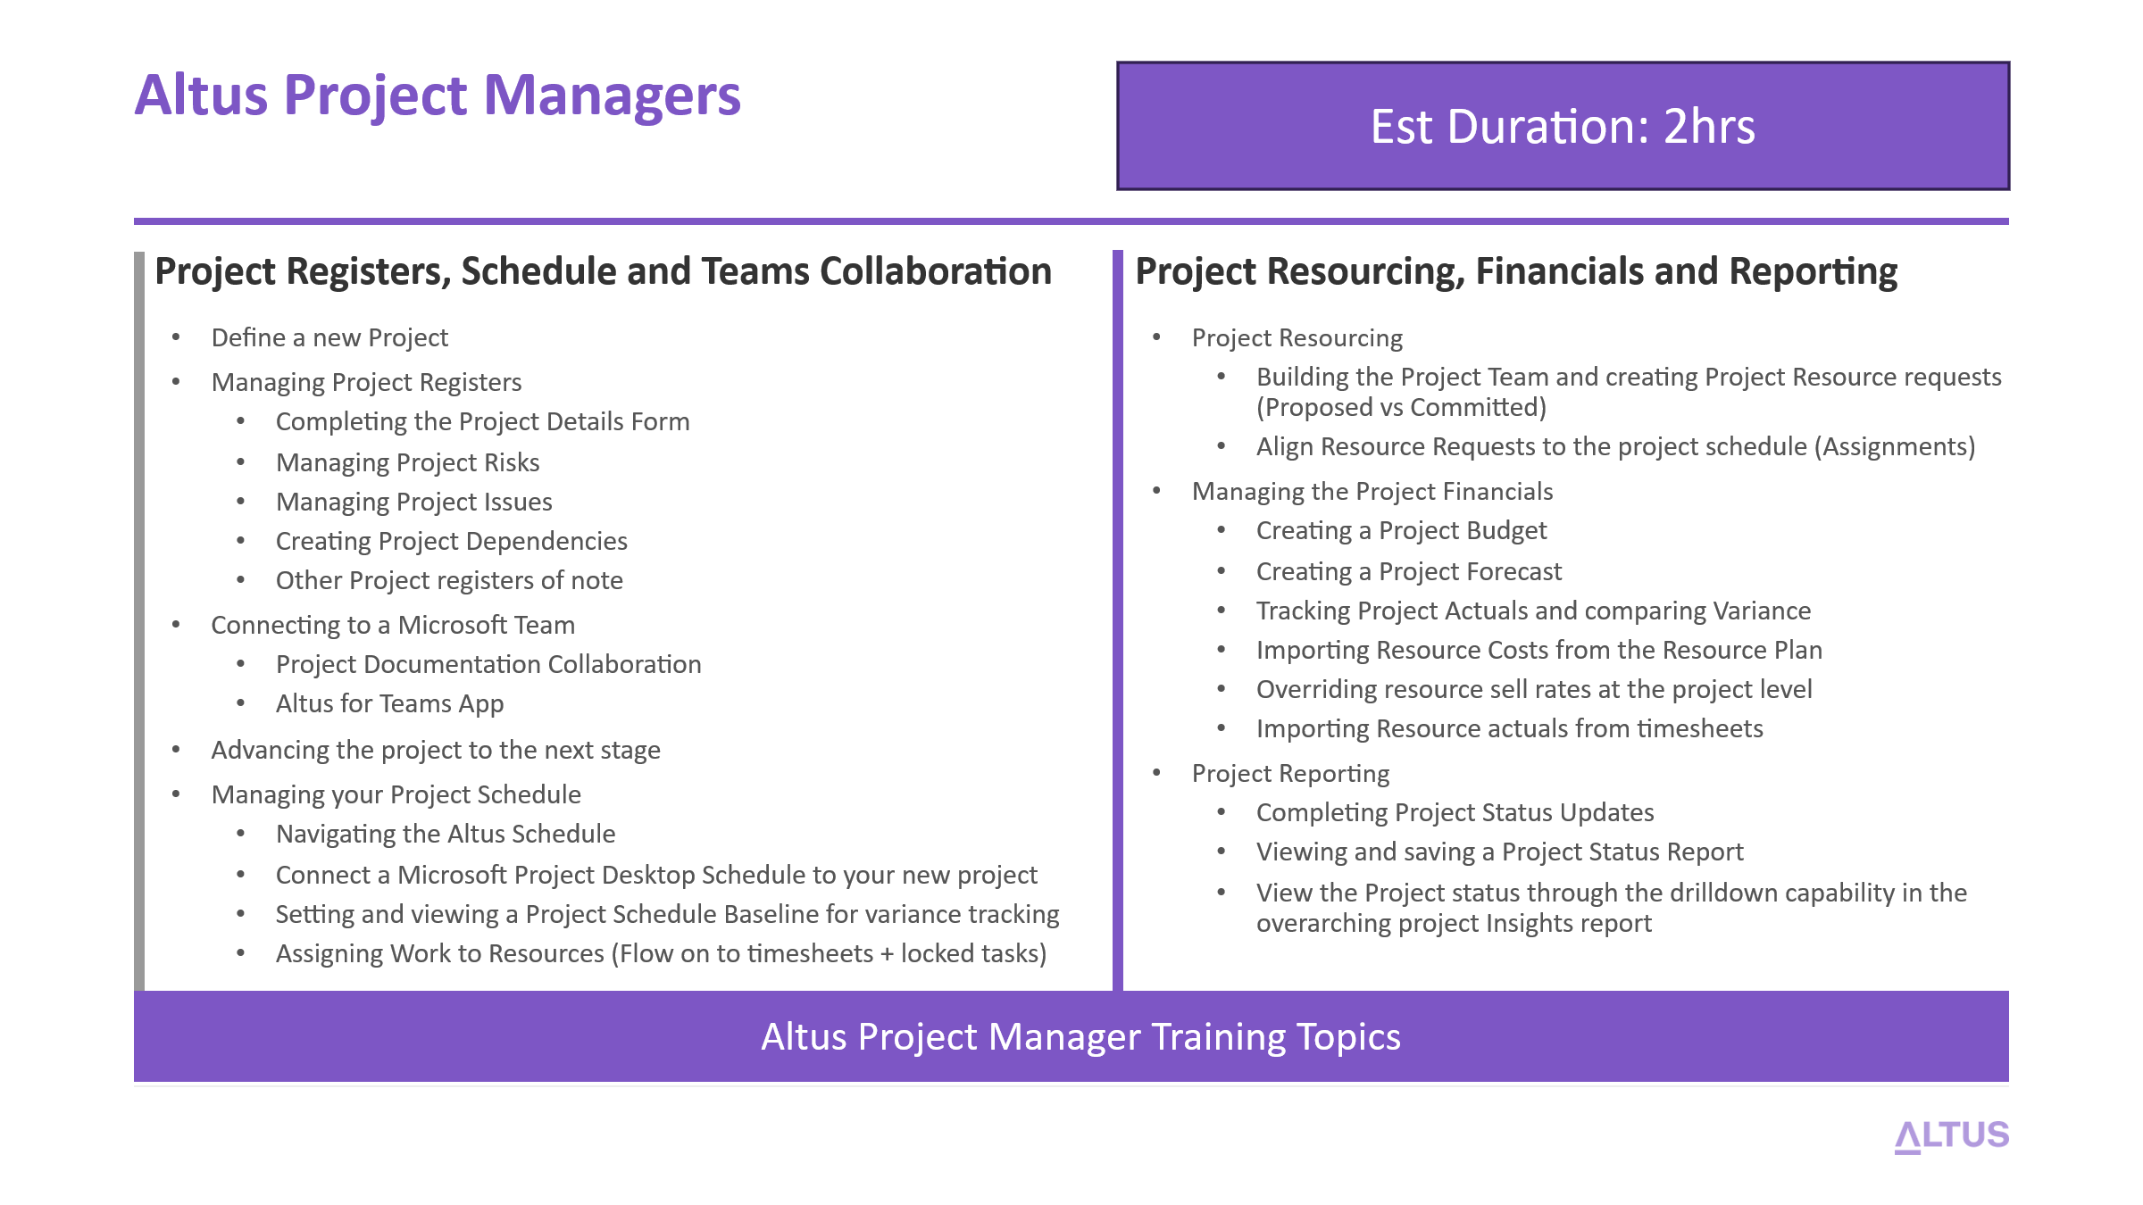

Team Member Training Agenda

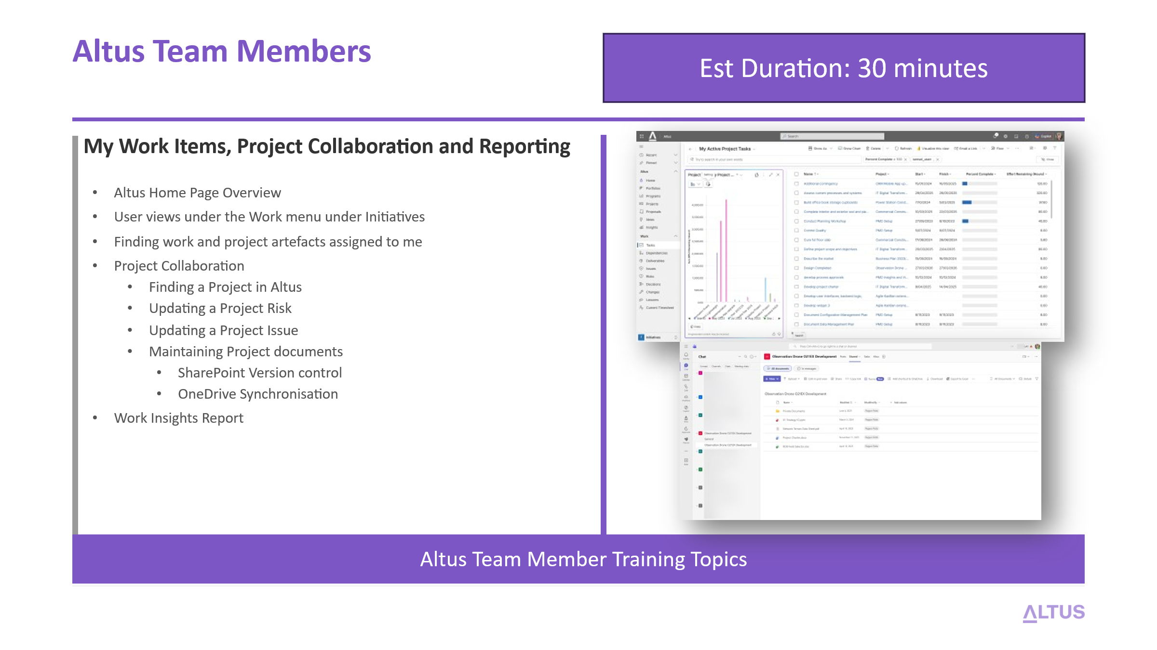
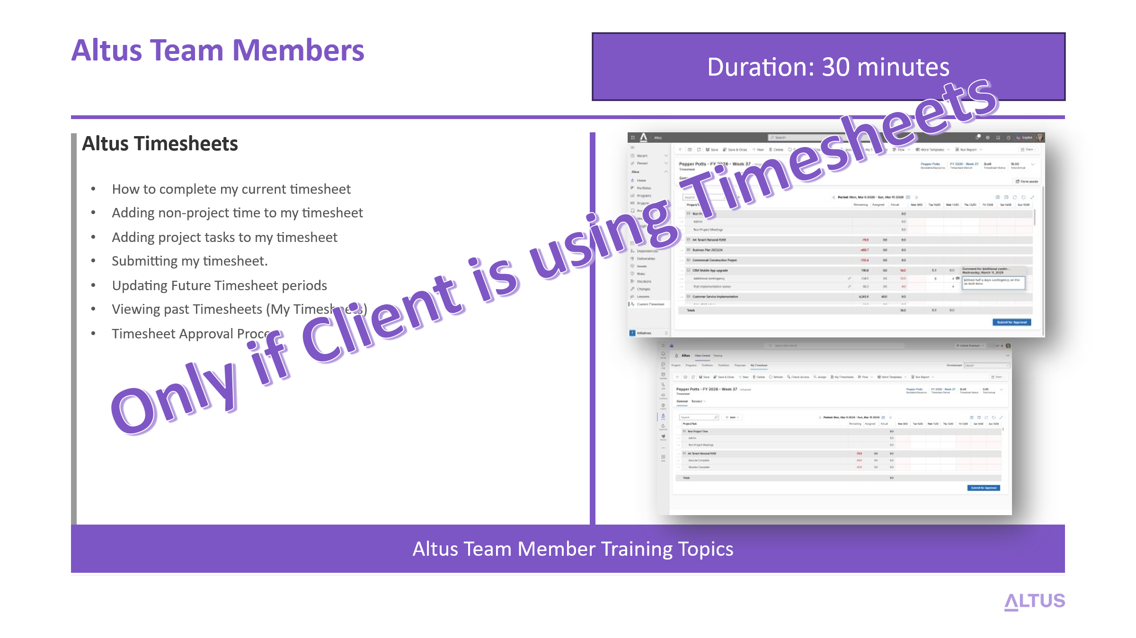

Post Go-Live Phase

Post Go-Live Phase Steps
ID | Task | Owner | Status | Notes
1 | Conduct the 1-week duration Priority support period | IC |  | The moment we have run all migration activities and reached the agreed formal Production go-live date, the 1-week duration priority support  Ensure project resources are on-standby to quickly triage and resolve issues raised in our central issues list within the shared project Team site.  Please refer to the ‘Issue Resolution Support Process’ section on further details of the support process.
2 | Send out the Post Implementation Review Survey | IC |  | Send out a post implementation review survey to the client’s key stakeholders to get a pulse on how the project went.  Whilst self-improvement is always a quality to monitor, give particular to questions that focus on the perceived gaps that can be handled in future iterations by an Altus Partner that fall outside the scope of the data migration so further conversations and assistance can be provided where needed.  Please refer to the ‘How to create a Microsoft Forms Poll/Survey’ section on further details of how-to setup a survey using Microsoft Teams.
3 | Conduct an Altus Partner handover | IC |  | NOTE: This step is only necessary if a client has directly engaged Altus where a Partner was not available to assist.  Setup a 1-hour session with the local Altus Partner initially to walk them through what was performed, what was discussed and where the client will need further assistance to ensure a smooth knowledge transfer.  Then coordinate and conduct an introduction meeting with both the partner and client to facilitate formal introductions and officially handover and close the migration project engagement.

Post Go-Live Phase Helper Guides

Testing and Issue Resolution Support Process
This section outlines the testing and issue resolution support process that will be followed during the Project Online to Altus migration implementation. The purpose of this process is to provide a structured approach for validating the solution, managing issues identified during testing, and ensuring that the Altus environment is ready for production use.
The process defines how testing will be conducted across the Development, Test, and Production environments within the client’s Microsoft 365 tenant, as well as the roles and expectations for both the implementation team and the client during the testing period. It also establishes a consistent method for logging, tracking, prioritising, and resolving issues through the shared project collaboration site.
By following this approach, the project team can ensure that configuration changes, migrated data, integrations, and user access are appropriately validated prior to go-live. This helps reduce risk, improve transparency in issue management, and support a smooth transition to the live Altus production environment, including the initial post–go-live priority support period.
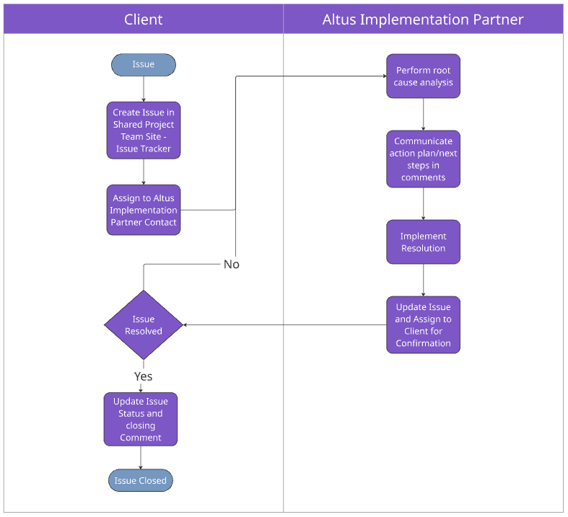

Altus Non-Production Environment
The Altus implementation will be delivered across three primary environments within the client’s Microsoft 365 tenant: Development, Test, and Production. Each environment serves a specific purpose in the deployment lifecycle, helping to ensure that configuration, migration activities, and validation are carried out in a controlled and structured manner before the solution is made available to end users.
Using this staged approach allows the implementation team to safely configure and validate the Altus solution, migrate and verify project data, and enable client stakeholders to conduct testing before the system is released for operational use. This environment structure reduces risk, supports quality assurance, and ensures that the Production environment remains stable and ready for business use at go-live.

Altus Development Environment
The Development environment is used by the implementation team to deploy and configure the Altus solution within the client’s Microsoft 365 tenant. This environment is used for solution configuration, migration preparation, testing of configuration changes, and validation of integrations or customisations before they are promoted to later environments. It provides a safe working space where changes can be made without impacting user testing or live operations.

Altus Test Environment
The Test environment is used to validate that the Altus solution configuration and migrated data operate as expected before being released to production. This environment is typically used for system testing and User Acceptance Testing (UAT) by nominated client stakeholders. It provides a controlled environment that mirrors production as closely as possible, allowing users to verify functionality, confirm business processes, and identify any issues prior to go-live

Altus Production Environment
The Production environment is the live operational environment where the Altus solution is used by the organisation’s end users to manage projects, portfolios, and related processes. Following successful testing and approval, the configured solution and migrated data are deployed to this environment for ongoing business use. Changes to this environment are controlled through agreed governance processes to ensure system stability and data integrity.

Considerations
The following considerations should be made during the testing phases of this project:
Consideration | Description
Availability of key testers | The client should nominate appropriate business representatives (for example PMO administrators, project managers, and team members) to participate in testing. These individuals should be familiar with current processes and able to validate whether the system behaves as expected following the migration.
Data validation | Users should review a representative sample of migrated projects to confirm that key information has migrated correctly. This may include project schedules, project metadata fields, financial information, risks and issues, and supporting documentation where applicable.
Security and access validation | Testers should confirm that the correct users and groups have access to the appropriate areas of the system. This includes validating permissions for PMO administrators, project managers, and team members to ensure security roles and Dataverse access are functioning as per the out of the box Altus security permissions assigned.
Testing of integrations and add-ins | Where applicable, users should confirm that supporting tools such as the Altus for Project Desktop add-in, Altus for Teams and Power BI reporting operate correctly with the migrated data and configured solution.
Change freeze during testing | To maintain a stable testing environment, a temporary change freeze should be applied during the UAT period. This ensures testers are validating a consistent configuration and avoids introducing new changes that could affect testing outcomes.
Test cases documentation | Creation of UAT test cases to cover functionality and business specific requirements is not in scope for this project. UAT is the responsibility of the Client to execute including developing end to end testcases and datasets for all required test types (functional and non-functional).
Client Specific Documentation | Any additional test or client specific documentation above what is already specified in the statement of work/description of services is out of scope for this engagement.

Test Stages
Activity | Description
Ad-hoc Unit Testing | Targeted testing performed by the implementation team throughout the configuration and migration process to validate that individual solution components are functioning as expected. This includes verifying configuration settings, data integrity following migration activities, integrations, security roles, and key functional areas within the Altus solution before the system is made available for broader user testing.
Final System UAT | A 3-day cycle of User Acceptance Testing (UAT) to be conducted by the Client immediately following the completion of the data migration. During this period, nominated client representatives will validate that the migrated data, configured functionality, and key business processes operate as expected within the Altus solution. It is mutually agreed that a change freeze will be in effect during this period to limit scope creep and ensure testing is conducted against a stable system baseline.
Priority Support Period (Post Go-Live) | A one-week priority support period commencing on the agreed production go-live date. During this time, the implementation team will prioritise the investigation and resolution of issues reasonably attributed to the data migration or solution deployment. All items logged within this period will be actioned and responded to as efficiently as practically possible, even if the resolution of those items extends beyond the one-week period. Issues raised after this support window may require additional effort and associated fees to investigate and resolve.

Issue Priority Definitions
Below is a description of the Issue Priority options and their definitions:
Priority | Description
Critical | A critical issue is one that prevents the system from operating, or blocks core functionality required for go-live or ongoing business operations. This type of issue typically affects many users or prevents key Altus capabilities from functioning, such as the inability to access the system, failure of the data migration, or major data integrity problems. Critical issues require immediate investigation and resolution and may delay testing completion or go-live until resolved.
High | A high priority issue significantly impacts important functionality but does not completely prevent the system from operating. These issues may affect specific business processes, user roles, or areas of the solution, such as incorrect behaviour in key configuration areas, issues with project schedule interaction, or problems with reporting or integrations. High priority issues should be addressed as soon as possible during the implementation or testing cycle to minimise disruption.
Normal | A normal priority issue represents a functional problem that has a moderate impact on usability but does not prevent users from continuing their work. These issues may involve non-critical configuration behaviour, minor data inconsistencies, or functionality that operates differently than expected but still allows the overall process to continue. These items are typically addressed as part of the standard issue resolution process.
Low | A low priority issue has minimal impact on system operation or business processes. These issues may include cosmetic display problems, minor usability concerns, documentation clarifications, or enhancement suggestions. Low priority items are typically recorded for later resolution or consideration in future configuration updates rather than requiring immediate action during the implementation period.

Issue Status Definitions
Below is a description of the Issue Status options and their definitions:
Priority | Description
New | The issue has been reviewed and is currently being investigated or actively worked on by the implementation team. Analysis, troubleshooting, or corrective actions are underway to determine the root cause and implement a resolution.
In Progress | The issue has been reviewed and is currently being investigated or actively worked on by the implementation team. Analysis, troubleshooting, or corrective actions are underway to determine the root cause and implement a resolution
Completed | The issue has been resolved, and the required corrective action has been implemented. The fix has been validated by the implementation team and, where applicable, confirmed by the client that the issue no longer occurs.
Blocked | Work on the issue cannot proceed due to a dependency or external factor preventing progress. This may include awaiting information, access, configuration changes, or decisions from the client or another party before investigation or resolution can continue.
Duplicate | The issue has been identified as a duplicate of another issue already logged in the issue register. The duplicate record is closed and linked to the original issue where the investigation and resolution will be managed.
By Design | Following investigation, the behaviour reported has been confirmed as the intended or expected behaviour of the system. No corrective action is required as the functionality is operating according to the design of the Altus solution or the underlying Microsoft platform.
Won’t Fix | The issue has been reviewed and acknowledged, but it has been agreed that no corrective action will be taken. This may occur where the issue has minimal impact, the effort required to resolve it outweighs the benefit, or it falls outside the agreed scope of the implementation.

How to raise an issue
- Navigate and login to the Project Online to Altus migration Team Site
- Under the General channel, select the Issue Tracker Tab and click the + Add new item button.
  - 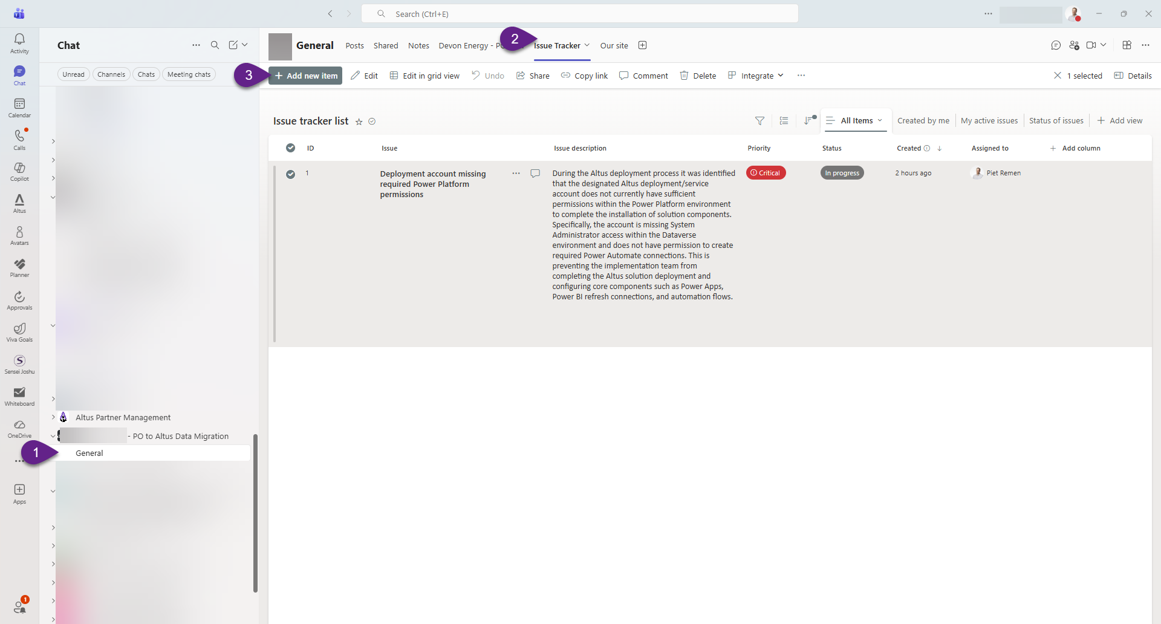
- Enter the name/title of the issue
- Click the pencil icon to edit the description area. Enter a detailed description, along with screen shots and steps on how to reproduce the issue to avoid vague time inefficiencies between the support technician and resolution time.
- Set the priority based on the following matrix: Issue Priority Definitions
- Set the Status appropriately based on the following matrix: Issue Status Definitions
- Assign the issue to the Altus Implementation Project Manager (IPM) or directly to another individual if known and available to select from.
- Note, the resolution area will be completed by the responding support technician, along with additional comments on status that will be attached to the issue item.
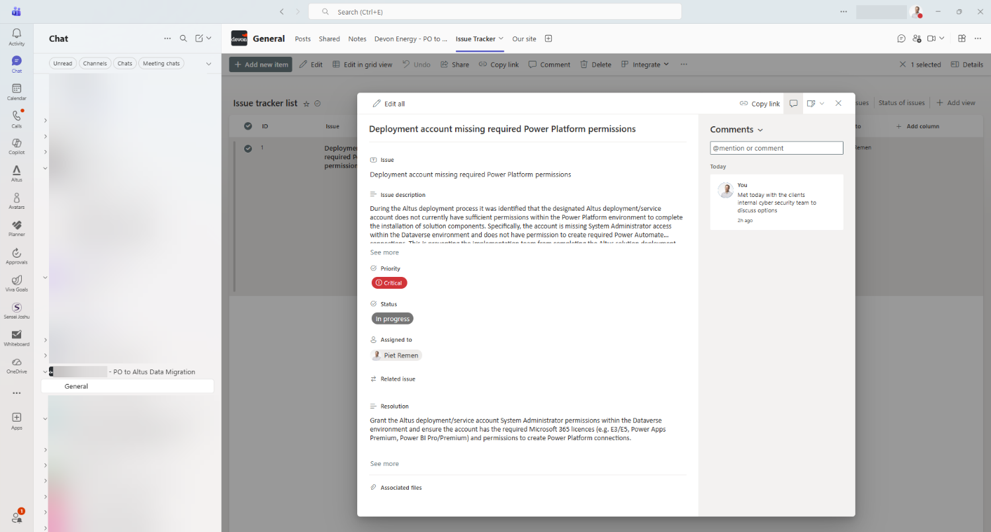

Altus one-week priority support Process
The purpose of the one-week priority support period is to provide focused post-go-live assistance during the initial transition to the new production environment. This period allows the implementation vendor to rapidly respond to any issues that may emerge once users begin operating in the live Altus production system, particularly those related to the completed data migration activities. It provides the project team with confidence that any migration-related concerns can be quickly assessed and addressed while the solution is being actively adopted by users.
By concentrating support during this early stage of production use, the vendor can efficiently validate that the migrated data is functioning as expected within the client’s environment and resolve any confirmed migration issues with minimal disruption to ongoing operations. This approach helps ensure a smooth stabilisation period immediately following go-live before transitioning the solution into standard ongoing support arrangements.
It is important to note that the one-week priority support period will commence on the agreed initial production go-live date. During this period, any issues logged that can reasonably be attributed to in-scope data migration activities will be reviewed, actioned and responded to by the implementation vendor as efficiently as practicable. Where investigation or resolution of these issues extends beyond the one-week period, the vendor will continue working towards resolution.
Issues raised after the one-week priority support period has concluded will fall outside the included support scope and may require additional fees for investigation and resolution.

How to create a Microsoft Forms Poll/Survey
Create a Microsoft Form Survey using the documented steps from the following Microsoft article:
https://support.microsoft.com/en-au/office/create-a-form-with-microsoft-forms-4ffb64cc-7d5d-402f-b82e-b1d49418fd9d
Send the form to the appropriate project stakeholders using these steps, noting people outside your organisation will need to use the ‘Anyone can respond’ option:
https://support.microsoft.com/en-au/office/send-a-form-and-collect-responses-2eaf3294-0cff-492d-884d-a1dee909e845

